[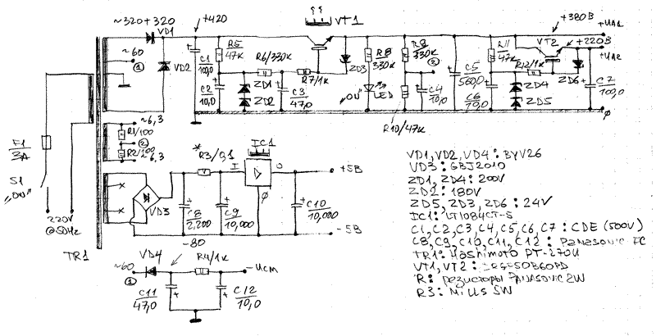](http://easytubeamp.com/inogda-oni-vozvrashhayutsya-chast-4-eshhe-raz-o-300v/300bse_sch_003/)

