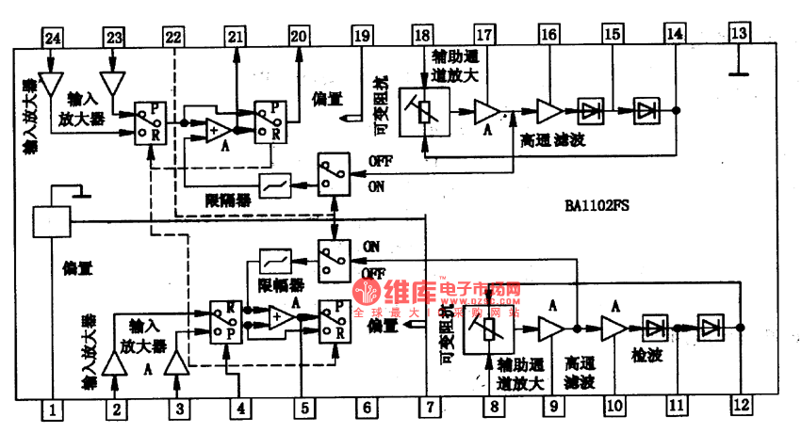

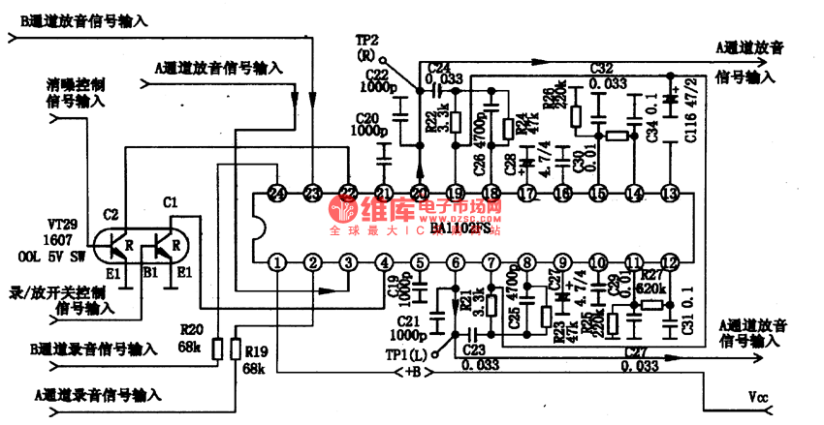

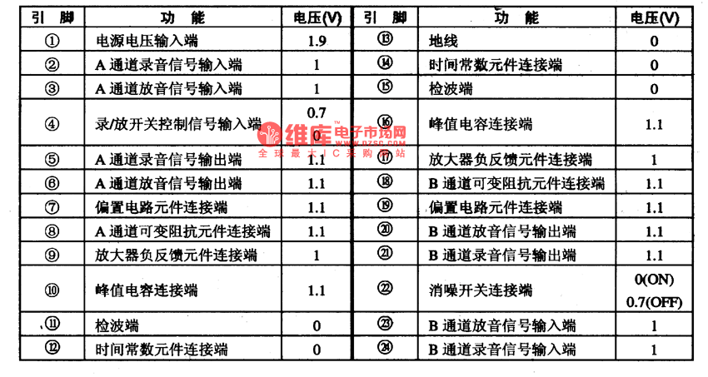

BA1102FS is an integrated Dolby B noise reduction circuit of single door produced by Toyo Power Tool Corp., Japan, which is widely used in all kinds of stereos to reduce the ground noise in recording/reproducing.1.the internal circuit and pin functions of BAll02FSBAll02FS contains sub-circuits of buffering amplifier, peak value suppression, feedback amplifier and assistant wave-detection channel amplifier, whose main characters are: two dependent noise reduction channels, electric recording/producing and noise reduction switches.This IC is in 24-lead dual line plastic package.