**Triodino III**

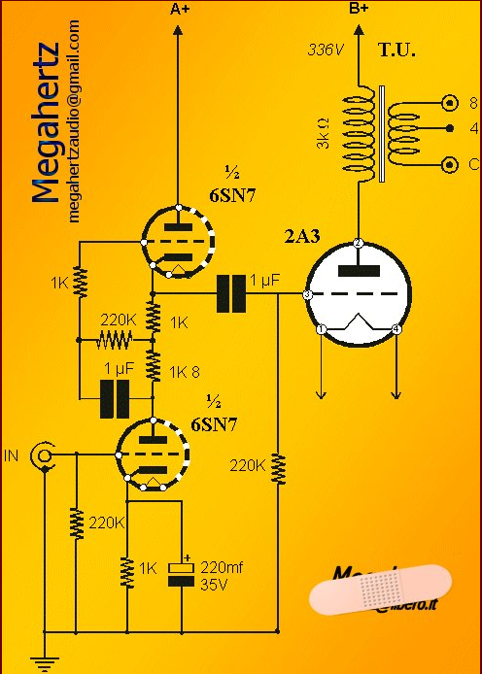

|  |  |
| --- | --- |
|  | [Home](http://www.diyaudio.com/) > [Forums](http://www.diyaudio.com/forums/) > [Amplifiers](http://www.diyaudio.com/forums/amplifiers/) > [Tubes / Valves](http://www.diyaudio.com/forums/tubes-valves/) |