1. YAMAHA A-s2200

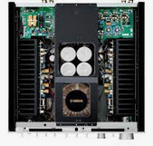

1. **Rotel RB-1582 MkII Silver**

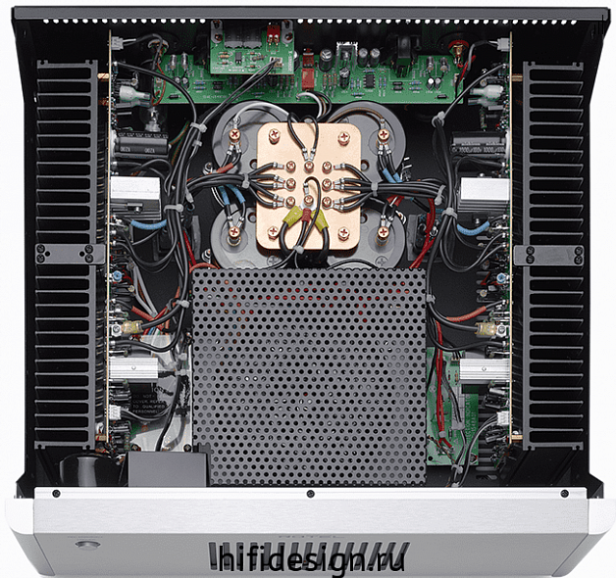

## Ordering PCBs at JLCPCB

|  |  |
| --- | --- |
| **Dimensions: 100х100мм** | **Dimensions: 250х100мм** |
| **Calculated Price**  ~~$4.00~~ **$2.00** | **Calculated Price**  **$13.40** |