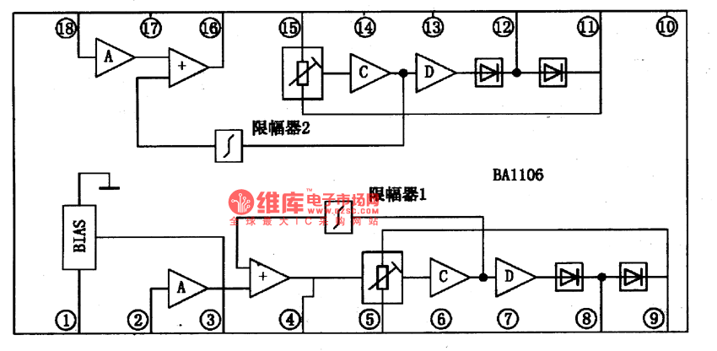

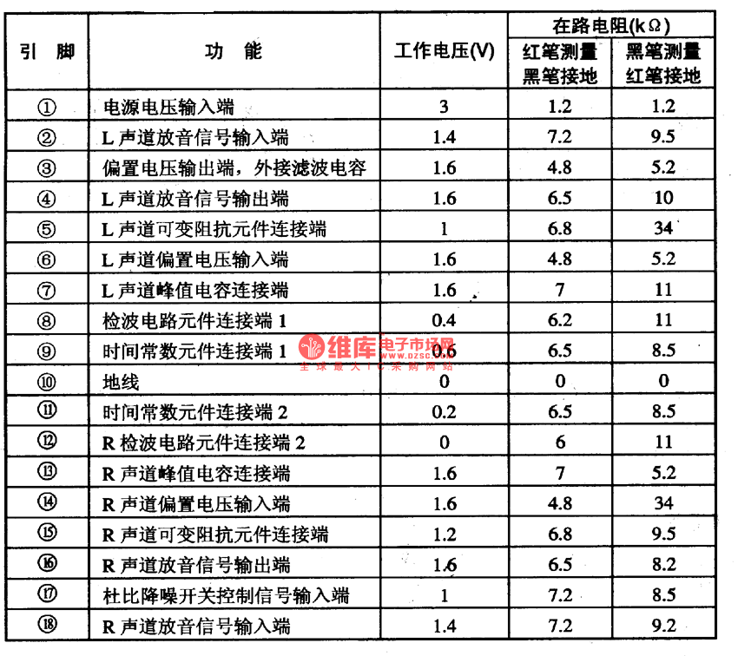

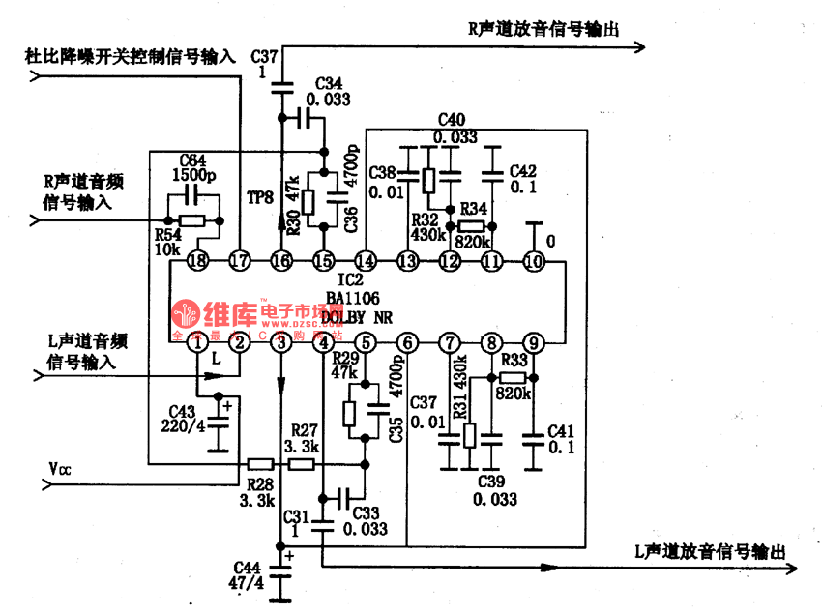

BA1106 is an Dolby B noise reduction integrated circuit produced by Toyo, Corp., Japan, which is widely used in walk-man, domestic stereos and car stereos.1.the internal circuit and pin functions of BA1106BA1106 consists of magnifier, adder, amplitude limiter and variable resistance, whose internal circuit is shown in Figure 1 and whose pin functions and working data are listed in Table 1. Figure 1 the internal circuit of BA1106 2.the typical application circuit of BA1106The typical application circuit of BA1106 shown as follows