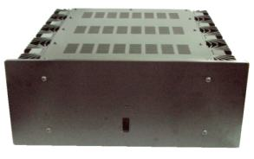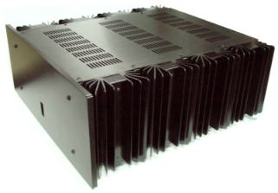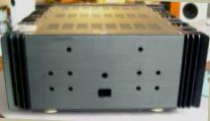 | 00003 Корпус для транзисторного усилителя мощности  Heat sink suitable for 45W+45W stereo or 90W under Mono Class A,  Overall size: 44cm(W) x 46cm(D) x 19cm(H)  Body size; 42 cm (W) x 45cm(D) x 17cm(H)  Panel size: 45cm (W)x 18cm(h)  Thickness: body(1.2mm), panel (10mm)  Heat sink size: 10.2cm(W) x 17cm(H) x 4.9cm(D) ,  with 8 pcs of heat sink  Pre-cutout/hole:  Panel Main switch; 36 x 28mm( recess 33 x 31 mm)  Led hole: 3mm dia  Back Panel; 2 hole for inputs(10mm dia)  Holes between(hole center to hole center) at 14.2cm  2 set of speaker out(each with 4 hole of 10mm dia.)  +/- Binding post holes between at 4cm, up and down at 3.5cm  Power Switch: 28 x 20 mm cut out  fuse hole in 12mm dia.  Finish: Black and champagne anode plating over alum. alloy.  PS: shipping with tan transistor NYLON protected cup, not as shown in photo for baked steel shield  *Limited quantity offer

