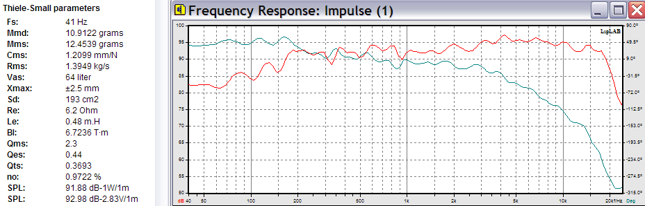

SWR 200-A wide range loudspeaker, AlNiCo, TS parameters and frequency response

