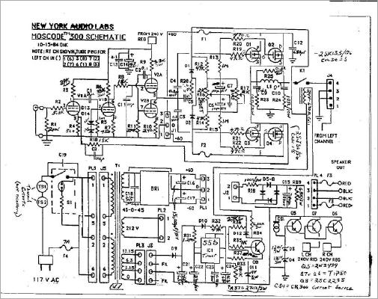
Moscode 300 Hybrid Amplifier Please click circuit for more details
MJ Musen to Jiken Hybrid amplifier
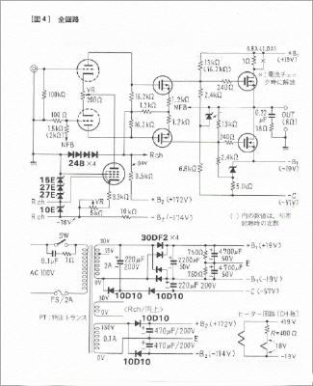
Hybrid design MJ Musen to Jiken Japan
Jurgen Ultee Hybrid amplifier
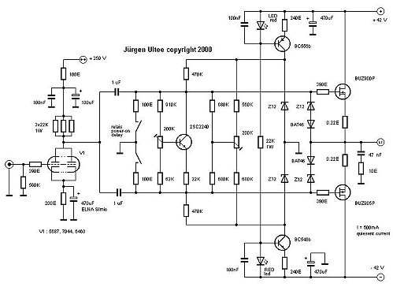
Hybrid Amplifier Jurgen Ultee, Germany [2000] Please click circuit for more details
