
Projects Library
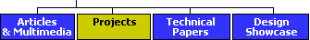

The 6N1P OTL Headphone Amplifier
by Bruce Bender
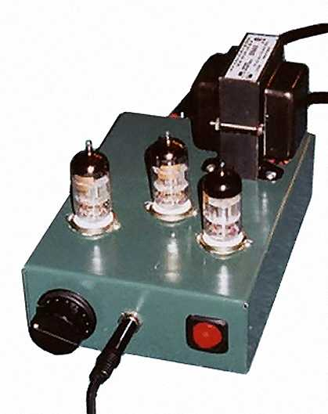
The HeadWize DIY forum is full of information about opamps for use in portable headphone amplifiers. The Pocket Amplifier by Chu Moy (a.k.a. the "CMoy amp"), especially with Carl Hansen's circuit board, is a great project. I built a few of those, but for my next project, I wanted to go a bit further and do something a little more discrete. Portability was not an issue for me, since most of my headphone listening is done at home in the living room where my stereo lives.
I have had the pleasure of using tube amplifiers and tube preamps of various types over the years, and I do believe that, all else being equal, tubes sound better than transistors. So I wanted to build a tube headphone amp. I also wanted a simple amp, especially the power supply. In a lot of tube projects the power supply can be more complicated than the audio circuitry. After reviewing the various tube headphone amp designs on HeadWize, as well as some circuits from other sources, I chose the Morgan Jones amp. I thought it would be a lot of fun to build an amp that uses only one kind of tube, to really get the flavor of that tube, and I also was interested in the output-transformer-less (OTL) circuit, with no global feedback.
I was intrigued by the Svetlana 6N1P tube. I much prefer to use tubes that are still being manufactured, having had very mixed results with new old stock (NOS) tubes. Svetlana was promoting a large lineup of tubes in the USA at the time, the 6N1P being one of them. The 6N1P has good performance curves, and supposedly is compatible/interchangeable with the 6922 family, although my experience seems to show otherwise. This amp is really optimized for the 6N1P tubes, so if you want to use 6922s you should use the circuit in the Morgan Jones article.
I also realized that this would be a good first tube project for HeadWizers that want to venture out from the world of opamps into the world of tubes. So I decided to document the project with narrative and a few pictures, to make it as straightforward as possible for anyone else to try it.
Like the original Morgan Jones amp, the original 6N1P OTL had trouble driving low impedance headphones. This version of the 6N1P OTL amp features a re-balanced output stage that gets all of my headphones plenty loud. Alex Cavalli ran PSpice simulations to get the new parts values. The rebalanced amp also needed a higher voltage power supply. For more information on the Morgan Jones amplifier or theory behind the optimization, see The Morgan Jones Mini Tube Amplifier. For more information on the basics of tube electronics, visit the Svetlana or Triode Electronics websites.
The Amplifier
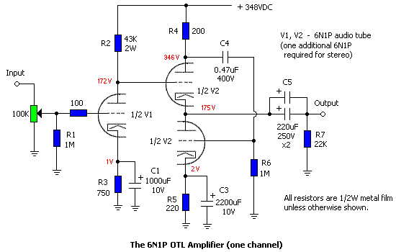
Figure 1
The amp is built according to the Morgan Jones design. In the spirit of DIY, I made a few modifications. I did not change the circuit topology at all, but used Svetlana 6N1P tubes, as noted. I also used a conventional power supply instead of the wall wart/filament transformer combination, because the 6N1P has a higher filament draw (2 amps) than 6922s, and I wanted plenty of high-voltage supply, too.
If you can read an op-amp circuit diagram, you should be able to read this tube circuit with no trouble. The 6N1P family are "dual triodes," each tube containing two separate amplifiers in the same device. Each triode has three circuit connections: a source of electrons ("cathode"), an output that receives the electron flow ("anode" or "plate"), and a "grid" which controls the flow. A separate wire filament (the orange glow in tubes) heats the cathode to make it give off electrons.
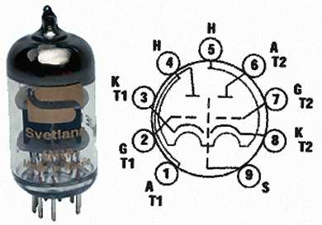
Figure 2
Figure 2 shows the tube pin layout. The layout is shown from underneath, from the bottom of the tube. This makes sense, since that is the view you have of the tube socket when wiring it. Pins 1, 2, and 3 are the anode (A), grid (G), cathode (K) for the first triode (T1) inside the tube. Pins 4 and 5 are for the filament heater (H). Pins 6, 7, and 8 are the anode, grid and cathode for the second triode (T2). Pin 9 is for shield (S) between the two triodes in the tube, and in this amp should be connected to ground. In the schematic, all the cathodes are shown on the bottom (the little hat shape signifies the heater filament), grids in the middle, anodes on top.
The Power Supply
The power supply shown for the original Morgan Jones amp is unusual and clever, but the 6N1Ps need a higher voltage for the plates and more current for the filament heaters than the original supply can produce. [Editor: The 6N1P needs a higher plate voltage than the 6922/6JD8 to reach its optimal operating range.] The heater current is 600mA for the 6N1P versus 365mA for the 6922, a significant difference. The clever wall-wart scheme, which is barely adequate for the 6922s, clearly can't provide enough current for 6N1Ps. So I used a more traditional power supply. Tube amps traditionally have a power transformer that has a separate winding for the heater filaments in addition to the main winding. As it happens, a transformer is available that provides usable voltages for this project, the Hammond 269AX.
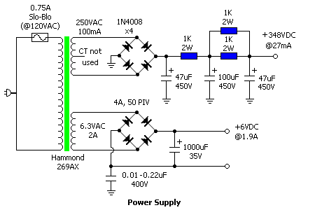
Figure 3
Figure 3 shows the power supply. The high voltage supply is 350V. Since the cathode-heater voltage of the top half of V2 then exceeds the 6N1P's spec of 100V, I floated the heater supply ground with a 0.22uF, 400V capacitor, so the whole circuit connects to ground only via this grounding capacitor. I don't know if 0.22uF is an optimum value for this use - I just had one on hand.
Do not use the center tap (red/yellow) on the high voltage secondary winding of the 269AX. Also, be careful if you run this power supply for very long without a load on it, since voltages will quickly accumulate into the 400 volt range. The amp will draw about 27 milliamps of current. If you want a dummy load to use when checking the power supply, you will need to cobble together a 13k ohm load capable of dispersing 10 watts.
The power supply output network has one 1K-ohm/2W and two 1K-ohm/2W film resistors in parallel. You can trim the output voltage by adjusting the value of the second 1K-ohm/2W pair slightly up or down from 500 ohms.
The first version of the power supply used A.C. straight out of the transformer to heat the filaments. The amp sounded fine, but had a very loud hum that didn't go away until the filament circuit was rectified as shown in the schematic.
Construction

With opamps, voltages are rarely above ±15 volts. With tubes, voltages are much higher, up to 1,000 volts. This project has voltages as high as 400 volts. This is serious stuff and needs to be treated with the respect it deserves. There are three basic rules when working with high voltages.
- Keep one hand behind your back. A very dangerous path for high voltage is from hand to hand, with your heart in between. It doesn't take all that much to stop your heart at these voltages if the timing is wrong.
- Use proper probes. About the only thing you should be doing to a live circuit is checking voltages or signals. Get clamping tips for your probes. Clamp the ground clip to ground. With the hand that is not behind your back, use the proper insulating probe tip on your voltmeter or scope. Be sure your voltmeter or scope is rated for at least 500 volts for this project.
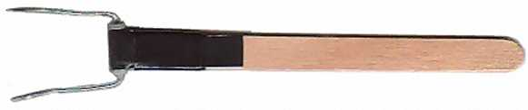
Figure 4
- Disconnect the power and DISCHARGE THE CAPACITORS before doing anything to the wiring. The capacitors in this project can give you a high-voltage jolt at much more than 27mA, and can hold that charge for a long time (e.g., an hour or more). Do NOT discharge the capacitors with the crude method of shorting the positive side of the caps to ground with an insulated screwdriver. I blew out a rectifier when I tried that. A better method is to bend a 10K-ohm/2W resistor into a "U" shape, tape the body of the resistor to the end of a popsicle stick, and use that to discharge the capacitors (figure 4). Measure the capacitor voltage with a meter to be sure it has drained all the way down: they don't discharge all at once, it takes 15 or 20 seconds.
And don't forget to discharge the audio output capacitors, too!
In the fine tradition of many tube amps, this project uses point-to-point wiring (meaning there is no printed circuit board or perf board involved). Most connections are made with solid 22 ga. copper wire, which stays in place after soldering, and does not flop around as stranded wire does. I also use ordinary solder from Radio Shack. To get good solder joints, you need to firmly connect the wires to be joined in a good mechanical joint, and then solder them. Keep everything dead still until the solder cools, or you may get a "cold" solder joint, which won't work well. If in doubt, just re-solder the connection.
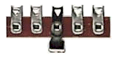
Download parts list for 6N1P OTL Amplifier
The building process for point-to-point wiring is different than when you are using a pc board or perf board. Instead of stuffing the board with components, and then putting it in a case, you start with the case and attach things. There is no "right" way to do this, but what follows is what works for me.
- Mount the physical parts on the chassis first.
- I used a steel chassis. Lots of tube equipment have been built this way, with the transformer and tubes on top of a steel chassis and the wiring inside, and that's what I prefer. Other folks seem to like aluminum, which they find easier to machine, but I don't see that much difference myself. At any rate, do not use plastic: you can't ground to it and it can't handle the heat from the tubes.
- This is probably the hardest part of the project. Making big holes in 20 gauge steel is tough. You need high speed drills of the proper sizes, and preferably a drill press. Center-punch each hole center before drilling to keep the drill bit from wandering until it takes hold. For holes bigger than 13mm, I used a nibbler ($10 from Antique Electronic Supply or Radio Shack) and patience.
A standard configuration for hard-wired audio tube amps is to put the transformer(s) and tubes on top of the chassis, and the wiring underneath/inside the chassis. I put the AC receptacle and input jacks on the rear panel. The transformer goes on top, in the back right corner (don't forget the holes for the wires) and the tube sockets go as close to the front as practical. Locate the tube sockets far enough back from the front panel so you can wire them with plenty of clearance for the volume control and power switch. The power switch, headphone jack, and volume control go on the front. (Personally, I like to have volume controls on the front panel, not on top.) Position the input jacks (in back) and volume control (in front) to the left side, as far from the power supply as possible. The power switch goes on the right.
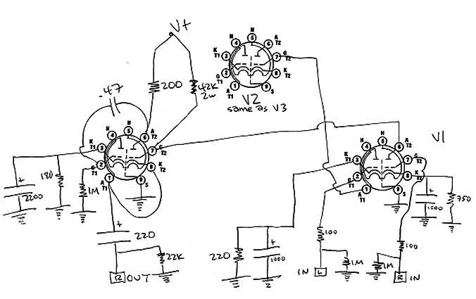
Figure 5
To wire the tube sockets, I wanted a physical wiring guide. I printed a piece of paper with three copies of the tube pin layout and then penciled in the various connections. I tried several layouts until I found one I liked. Shown above (figure 5) is my wiring guide for an earlier version of the amplifier.
Once you have made all the holes, file down any rough edges. Test fit all the pieces. Drill pilot holes for the mounting screws. Test fit each component. Then, when everything fits, stop and paint the chassis and cover before mounting the hardware.
If you use the Hammond chassis in the parts list, it is already painted grey. I marked it up doing the layout for the parts, so I roughed it up with sandpaper and painted it. I used "American Accents Hunt Club Green Satin" by Rustoleum and do not especially recommend it, since it looks a bit like plain old olive drab. After painting, you really should let the paint dry for two days. Otherwise, it scrapes off easily. Once the amp is up and running, it gets warm enough to "bake" the paint somewhat, and you can smell the paint baking for the first week or two.
Once the paint is dry, mount the hardware. Use machine screws and nuts and do not forget the star-type lockwashers. (The fasteners are not on the parts list - I get this kind of small mechanical stuff from a local hardware store.) Do not use sheet metal screws to mount anything other than the cover, as you will be sorry in a year or two if you do. The heat/cooling cycle will loosen up the sheet metal screws eventually. Based on my experience, in the worst cases you can only tighten sheet metal screws down a few times before they start to get sloppy and refuse to tighten up any more. Also, they leave a sharp point exposed on the inside of the chassis.
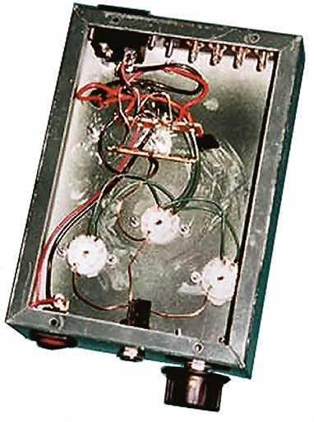
Mount the tube sockets, but leave the tubes safe in their boxes until it is time to fire the amp up. I wired the power supply first. I put two terminal strips side-by-side on one of the transformer mounting bolts. Sand down to bare metal under the feet of the terminal strips to get a good ground connection.
Make a ground bus (the bus is just a common wire for grounding everything). The middle lug of the terminal strips is used for ground. I didn't have any fancy bus wire, so I just stripped some of the 22ga solid copper wire, and made a ground layout.
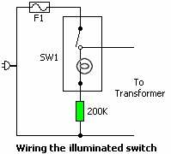
Figure 6
On the self-illuminated switch from Radio Shack, there are three connections, two of which act like a regular SPST switch. The third connector shows an open circuit with the other two no matter what position the switch is in. That is the one with the neon bulb in it: neon bulbs have infinite resistance until they reach their working voltage, and then they arc across to create light. So wire the center lug to AC line in and the regular switch lug to the transformer primary hot side. The 200K resistor connected to the third lug dims the light a bit because otherwise it is too bright.
At $35 (US), the Hammond 269AX is the single most expensive part of the project, but then again the transformers usually are in a tube project. The heater filament winding can provide 2A at 6.3VAC, and the high voltage winding is 100mA at 250VAC. Since the nominal current draw of the amplifier is 27mA, that allows plenty of reserve. Hammond makes a 369AX, which has the same specs as the 269AX but a "universal" primary winding that accommodates line voltages from 100VAC to 240VAC.
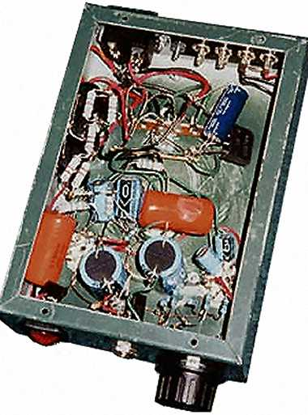
Physically locate the six large audio circuit capacitors. You want to be sure there is room for them, but put them in last, since they are very difficult to work around. The rest of the wiring is kind of like building a layer cake. The upside-down chassis is like a cake pan, and you want to build layers in the pan from the bottom up. As you wire each component, the leftover wire ends that you clip off have a tendency to fall down into the chassis. It only takes one stray wire end to cause a short circuit. With a chassis this small, it is a good habit to turn the chassis right-side-up and shake them out as you go along, right after they fall in.
Proper point-to-point wiring practice says that you should run anything with an alternating current in twisted pairs. This would include power supply wiring as well as signal wiring. I didn't do this, as the photos show. Shame on me!
Wire each tube socket, and try to get the best fit for the resistors and small capacitors, making them physically secure and unlikely to short against each other. Then wire the input circuits. The last step is to install the six large capacitors (four 220uF electrolytics plus the two 0.47uF 400v orange drop film capacitors).
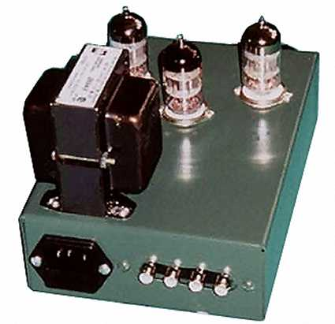
As usual with a prototype, the wiring in my amp looks a bit like a rat's nest, since I unsoldered and resoldered almost everything, for one reason or another, before I was done. But it all fits in easily. There is plenty of room for a crossfeed filter near the input jacks if you want to put one there. (I use a Jan Meier crossfeed filter, but have it in a small project box connected between the CD player and the amp.) Once you are done wiring, look everything over systematically to make sure that all is wired properly. If you can, have someone else look it over, too. The wiring guide is handy for this.
Testing the Amplifier
Put the tubes in the tube sockets. Do not put the bottom cover on yet. Prop the amp securely on its side so you can get at the wiring inside. If you have access to a Variac, use it to slowly bring the voltage up to line level. Otherwise, the fallback method is to stand back and turn it on. Once in a while electrolytic capacitors have been known to pop, and they can spit small amounts of hot gel when they go, so make sure your hands and eyes are several feet away and out of range. If nothing hisses, pops, splutters, or explodes you are halfway there.
The best way to test the high voltage supply is actually to power up the amp with the tubes in place; otherwise the power supply voltages climb up to 400v+ with no load, which doesn't really say much. To trim the high voltage supply, change the value(s) of the paralleled 1K, 2W resistors. These should probably be decreased to get the voltage up to around 350v. I doubt people are going to have problems with the output being much higher than that. Given the 6v tube-to-tube variation I observed, I would think anything between 340 and 360 volts should be fine. When I run the amp and watch it for 30 minutes or so, the high voltage supply drifts slowly up or down a volt or two, but the average is pretty close to 349 volts.
Checking the tube filament supply requires the tubes be installed in the sockets and be at operating temperature. The heaters draw about as much current as the transformer can produce, so it pulls the DC voltage down to about 6V. After the amp was assembled, I measured about 1.9 amps at 5.9 volts. Once the power supply works, wire the audio circuit. Do not forget to discharge the power supply and output capacitors first!
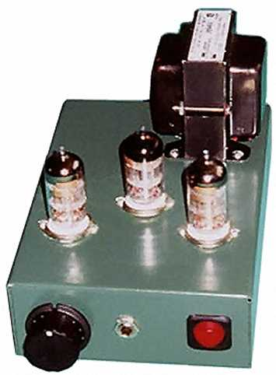
Remembering the safety rules about high voltages, check the voltages at the locations shown in red on the circuit diagram. My line voltage is high, measuring between 122 and 123 volts (the power substation is only a few hundred yards away). With the 6N1Ps in the circuit, I measured 172v at the junction of R2 and V1; 346v at the junction of R4 and V2; 175v at the positive side of the output capacitor; and 1.0v at the cathode of V1. The voltages should be within a few volts of these measurements, and the channels should be within a few volts of each other. If these check OK, shut things down, discharge the capacitors, give it one last visual inspection, and put the bottom cover on. Set it on its feet, and away you go!
Troubleshooting
I'm not good enough at troubleshooting myself to be of much help to others, but here's my general approach.
- Something is wired wrong!!??
- Missing or cold solder joint? It's easy to skip one when soldering a number of joints. Cold solder joints usually look dull instead of nice and shiny. They are easier to get when doing point-to-point wiring than when wiring a pc board - you need to be sure that nothing moves until the solder is set. Cold solder joints sometimes don't conduct electricity at all, or they cause noise or have high resistance. If in doubt of a connection, re-solder it.
- Really, something is wired wrong!!
- Defective part? Not very likely since tube stuff is pretty rugged, but I suspect capacitors first. Use new-manufacture tubes at first until everything is OK for sure. Then if you get a bum NOS tube you will be able to tell that it's the tube.
- Don't be embarrassed to ask for help on the Headwize DIY forum - that's what it's there for!
The Results
I am not a "golden ear". I am a musician and have been an audiophile since I was quite young. I don't believe in detailed "audio memory" that lasts more than a minute or two, so need repeated side-by-side comparisons to evaluate things. My primary headphones are the Sennheiser HD565 (150 ohms and 97dB/mW), AKG K501 (120 ohms and 94dB/mW) and Sony V6 (64 ohms and 106db/mW). My basis for comparison is the CMoy/Hansen amp (the single 9V battery version), which I think sounds pretty good, and the headphone jack of the NAD 314 (no crossfeed). I have a separate crossfeed I can use with the 6N1P amp - it's one of the Jan Meier types, but I don't remember which curve I followed.
Being a bass player and a drummer, I chose several of my favorite bass-player albums to use as test discs with my Denon DCM-370: "Outbound" HDCD by the Flecktones; Matthew Garrison's self-named CD, "Bent" by Gary Willis. The last also features monster drummer Dennis Chambers. The big difference between the earlier version of the 6N1P amp and this revised version is that the new version is capable of ear-splitting volumes driving the Sonys and the Senns, and also gets very loud with the K501s. The older version worked but only at polite volume levels.
There are much bigger differences between the three headphones than there are between the three amps. All three amps make the Sonys sound like Sonys and so forth. I didn't notice a lot of difference in sound field and imaging between the three amps, taking crossfeed into account as best I could. The CMoy/Hansen amp is a good standard of comparison, since lots of people have heard it by now. It has a typical solid-state sound: punchy and a little raspy in the upper midrange. At high volumes, the bass gets a little thin - it's still loud, but it loses some of its rounded character.
Whatever NAD put in the 314 headphone jack, it sounds surprisingly good. It has better octave-to-octave balance than the cmoy/Hansen, eg. a more even frequency response. At loud volumes the bass is smoother and rounder than the cmoy amp. The NAD (obviously) doesn't have crossfeed, though.
The 6N1P OTL stays smooth at high volumes, the treble is a bit more laid back than the solid state amps, but just a bit. The tube amp is just as punchy (a benefit of OTL) and the bass is very full and round, especially when using crossfeed. The amp has that tube "sweetness", but I have to say that the NAD sounds almost as "sweet", meaning a lack of harshness or "grain" in the sound. With the Meier crossfeed connected to the 6N1P OTL, the Senn HD565s have almost too much bass for my tastes, but without crossfeed they are just about right. Conversely, the AKGs sound a little thin without the crossfeed, but just right with it. For long listening sessions, I think the 6N1P amp, with crossfeed, with the K501s, is a very good sounding and low-ear-fatigue setup.
Overall, I can't really identify a "tube sound" with the 6N1P amp. It just sounds very good and very smooth. I am happy with it, happy enough that I have stopped longing for a directly heated triode output transformer-less headphone amp.

Appendix 1: Simulating the 6N1P OTL Amplifier
Editor: This section discusses how to use OrCAD Lite circuit simulation software to simulate the optimized 6N1P OTL amplifier. OrCAD Lite is free and the CD can be ordered from Cadence Systems. At the time of this writing, OrCAD Lite 9.2 is the latest version. OrCAD Lite 9.1 can be downloaded from the Cadence website (a very large download at over 20M) and should work as well. There are 4 programs in OrCAD suite: Capture, Capture CIS, PSpice and Layout. The minimum installation to run the amplifier simulations is Capture (the schematic drawing program) and PSpice (the circuit simulation program).
Download Simulation Files for the optimized 6N1P OTL Amplifier
Download OrCAD Triode Simulation Libraries
After downloading 6n1potl_sim.zip and orcad_triodes.zip, create a project directory and unzip the contents of the 6n1potl_sim.zip archive into that directory. Then extract the contents of the orcad_triodes.zip archive into the <install path>\OrcadLite\Capture\Library\PSpice directory. The files triode.olb and triode.lib are libraries containing simulation models for several popular types of triode vacuum tubes, including the ones used in this amplifier. They are based on tube SPICE models found at Norman Koren's Vacuum Tube Audio Page and Duncan's Amp Pages. Note: heater connections are not required for any of the triode models.
The two basic types of simulation included are frequency response (AC sweep) and time domain. The time domain analysis shows the shape of the output waveform and can be used to determine the amplifier's harmonic distortion. They both run from the same schematic, but the input sources are different. For the frequency response simulation, the audio input is a VAC (AC voltage source). The time domain simulation requires a VSIN (sine wave generator) input. Before running a simulation, make sure that the correct AC source is connected to the amp's input on the schematic.
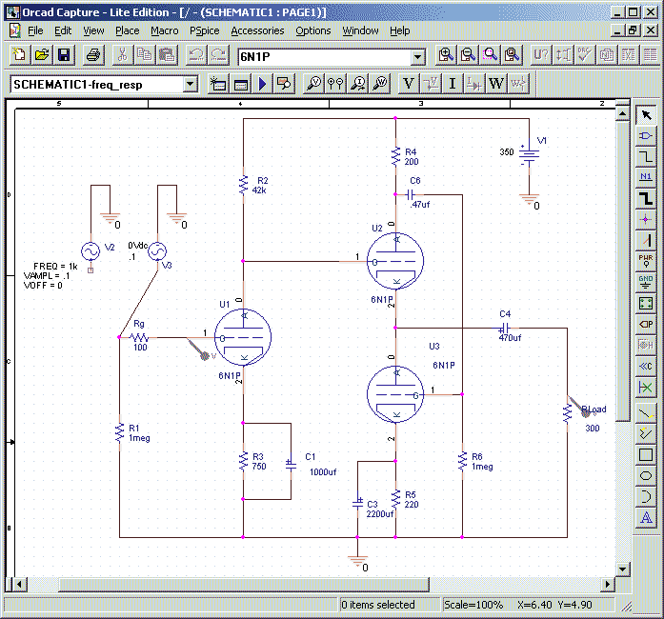
The following instructions for using the simulation files are not a complete tutorial for OrCAD. The OrCAD HELP files and online manuals include tutorials for those who want to learn more about OrCAD.
Frequency Response (AC Sweep) Analysis
- Run OrCAD Capture and open the project file "6n1potl.opj".
- In the Project Manager window, expand the "PSPICE Resources|Simulation Profiles" folder. Right click on "Schematic1-freq_resp" and select "Make Active."
- In the Project Manager window, expand the "Design Resources|.\6n1potl.dsn|SCHEMATIC1" folder and double click on "PAGE1".
- On the schematic, make sure that the input of the amp is connected to the V3 AC voltage source. If it is connected to V2, drag the connection to V3. By default, V3 is set to 0.5V. (Note: the tubes in the OrCAD schematic are labelled U1, U2 and U3. In the article schematics, they are referred to as V1, V2a and V2b.)
- To add the triode library to the Capture: click the Place Part toolbar button (). The Place Part dialog appears. Click the Add Library button. Navigate to the triode.olb file and click Open. Make sure that the analog.olb and source.olb libraries are also listed in the dialog. Click the Cancel button to close the Place Part dialog.
- From the menu, select PSpice|Edit Simulation Profile. The Simulation Settings dialog appears. The settings should be as follows:
Analysis Type: AC Sweep/Noise
AC Sweep Type: Logarithmic (Decade), Start Freq = 10, End Freq = 100K, Points/Decade = 100
- To add the triode library to PSpice: Click the "Libraries" tab. Click the Browse button and navigate to the the triode.lib file. Click the Add To Design button. If the nom.lib file is not already listed in the dialog list, add it now. Then close the Simulation Settings dialog.
- To display the input and output frequency responses on a single graph, voltage probes must be placed on the input and output points of the schematic. Click the Voltage/Level Marker () on the toolbar and place a marker at the junction of R9 and the grid of U1. Place another marker just above R_{Load} at the amp's output.
- To run the frequency response simulation, click the Run PSpice button on the toolbar (). When the simulation finishes, the PSpice graphing window appears. The input and output curves should be in different colors with a key at the bottom of the graph.
- The PSpice simulation has computed the bias voltages and currents in the circuit. To see the bias voltages displayed on the schematic, press the Enable Bias Voltage Display toolbar button (). To see the bias currents displayed on the schematic, press the Enable Bias Current Display toolbar button ().
Time Domain (Transient) Analysis
- On the Capture schematic, make sure that the input of the amp is connected to the V2 sinewave source (the default values are: VAMPL=0.5, Freq. = 1K, VOFF = 0). If it is connected to V3, drag the connection to V2.
- In the Project Manager window, expand the "PSPICE Resources|Simulation Profiles" folder. Right click on "Schematic1-transient" and select "Make Active"
- From the menu, select PSpice|Edit Simulation Profile. The Simulation Settings dialog appears. The settings should be as follows:
Analysis Type: Time Domain(Transient)
Transient Options: Run to time = 10ms, Start saving data after = 0ms, Max. step size = 0.001ms
- To display the input and output waveforms on a single graph, voltage probes must be placed on the input and output points of the schematic. Click the Voltage/Level Marker () on the toolbar and place a marker at the junction of R9 and the grid of U1. Place another marker above R_{Load} at the amp's output.
- To run the time domain simulation, click the Run PSpice button on the toolbar (). When the simulation finishes, the PSpice graphing window appears. The input and output curves should be in different colors with a key at the bottom of the graph.
- To determine the harmonic distortion at 1KHz (the sine wave frequency), harmonics in the output waveform must be separated out through a Fourier Transform. In the PSpice window, press the FFT toolbar button (). The PSpice graph changes to show the harmonics for the input and output waveforms. The input and output curves should be in different colors with a key at the bottom of the graph.
- The fundamental frequency at 1KHz will have the largest spike. The other harmonics are too small to be seen at the default magnification. In the PSpice window, press the Zoom Area toolbar button () and drag a small rectangle in the lower left corner of the FFT graph. The graph now displays a magnified view of the selected area. Continue zooming in until the harmonic spikes at 2KHz, 3KHz, etc. are visible.
- Harmonic spikes should exist for the output waveform only. The input is an ideal sine wave generator and has no distortion. To calculate total harmonic distortion, add up the spike values (voltages) at frequencies above 1KHz and divide by the voltage at 1KHz (the fundamental).
Additional Simulation Tips
- To change the value of any component on a schematic in the Capture program, double-click on the value and enter a new value at the prompt.
- To measure the grid-cathode voltage of tubes (V_{gk}), use the Voltage Differential Marker (). Click the Voltage Differential Marker toolbar button and touch the probe to the tip of the grid pin and then cathode pin.
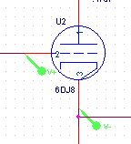
Note: simulations only approximate the performance of a circuit. The actual performance may vary considerably from the simulation as determined by a number of factors, including the accuracy of the component models, and layout and construction techniques.
For the latest updates, see the Project Addendum.

c. 2002 Bruce Bender.
Questions or comments? Visit the HeadWize Discussion Forums.
-


