My Amply Performances

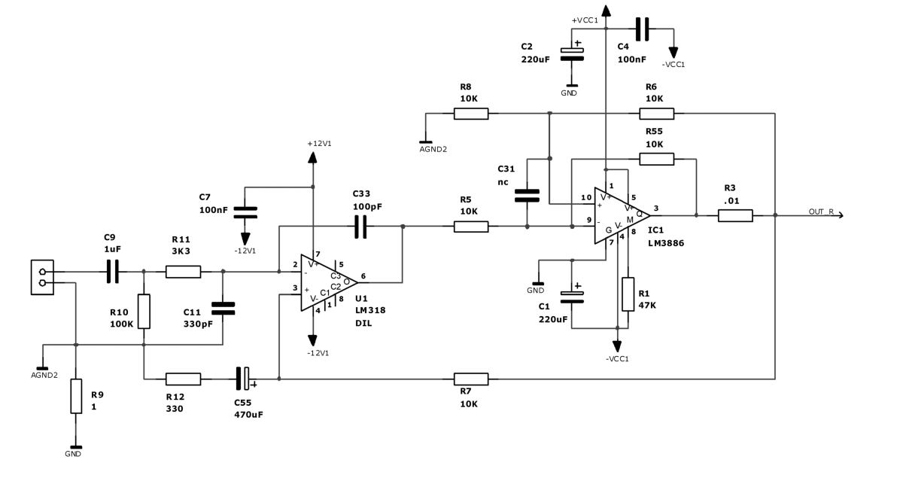

Setup:

Audio Generator (THD ): Blackstar LDO100 Low distorsion (-90 dB) analog sine gen.
Another Generator (Dumping): TTI TD1010 DDS functions gen.
FFT analysis: Pico scope ADC216 16bits 166khz PC instruments

Others: Various load

- all the measurements have been done on my prototype.
- Power Supply on Transformer 240/25+25Vac 225VA @ 235Vac Main Supply (+-37 Vcc)

Target data:

Power Output. 40W 8Ohm load (55W 8ohm unclipping) @ 650 mVrms
70W 4Ohm load

Dumping Factor: >300 20-30Khz @ 8 ohm Load

Frequency Response (-3dB 1W 8ohm): 2Hz -110Khz

S/N: >90dB

My- Ampli 1Khz 50W – 8ohm THD:

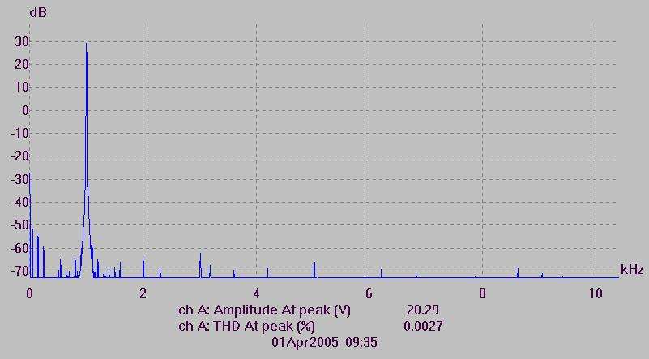

My- Ampli 1Khz 80W – 4ohm THD:

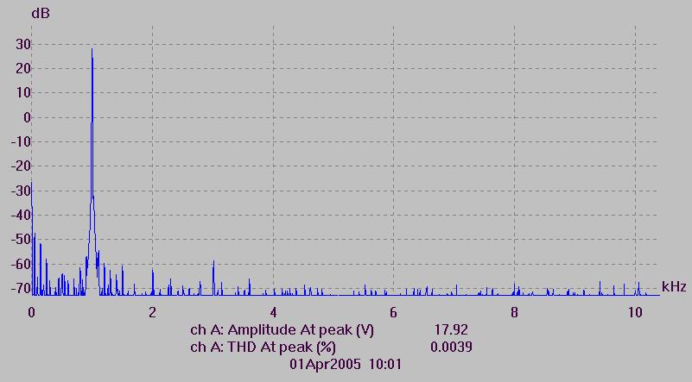

My- Ampli 10Khz 10W – 8ohm THD:

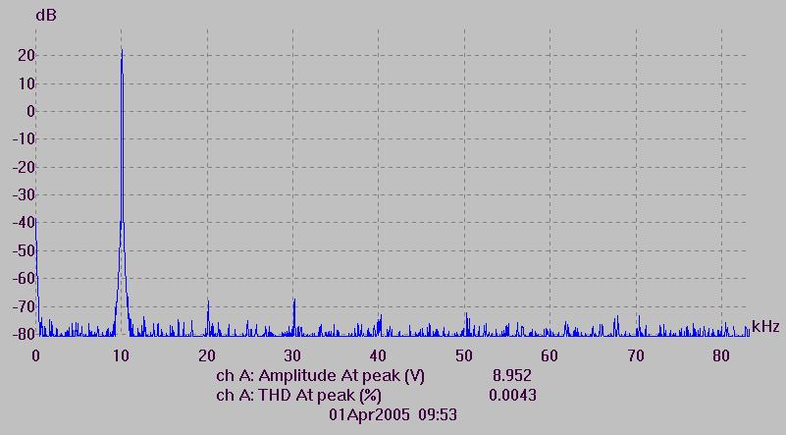

My- Ampli 10Khz 50W – 8ohm THD:

