A New High Slope, Linear Phase Crossover Using the Subtractive Delayed Approach

John Kreskovsky
©December 2002
revised April, 2005

Introduction

My interest in crossover design has, for a long time, centered about the desire to achieve speaker systems which have no crossover induced time domain distortion. As such I have been keenly interested in crossovers that sum to a zero or linear phase response. There have been numerous approaches to these types of crossovers. The simplest and most well known is the straight forward 1st order Butterworth (B1) crossover. The advantage of the B1 crossover is its perfect transient response. However, it has many disadvantages: 1) it is extremely difficult to achieve a crossover with a true B1 acoustic response; 2) it exhibits a polar response with tilted main lobe; 3) it offers insufficient protection for all but the most robust tweeters. Small [1] introduced the concept of constant voltage or CV crossovers which were derived by subtractive methods. A suitable base high pass (HP) or low pass (LP) response is chosen and the complimentary response is obtained by subtracting the base response from the input. Given that the input has flat amplitude, zero phase response, the sum of the base and complimentary filters will have also flat amplitude, zero phase characteristic by construction. However, these types of crossovers also suffer from several disadvantages. Assuming that the base filter is taken to be 2nd order or higher in nature: 1) the complimentary response function will always have a 1st order roll off; 2) the complimentary filter will have a humped response with amplitude exceeding unity over some portion of its response; 3) the interdriver phase difference will exceed 90 degrees meaning that the flat summed response is dependent on cancellation between the HP and LP response; 4) the off axis response is further degraded by the greater than 90 degree interdriver phase difference. Small [1] and Lipshitz and Vanderkooy [2] also looked at linear phase crossovers with symmetric, higher order HP and LP responses and in particular Kreskovsky [3,4] examined and generalized the special case of the 2nd order symmetric crossovers using equalization. Of these only the generalized 2nd order approach of Kreskovsky seems practical. However, as with the 1st order and CV crossover there are draw backs: 1) the HP and LP responses must overlap negating somewhat the improved tweeter protection of the 2nd order roll off; 2) both HP and LP responses have regions where the gain exceeds unity requiring cancellation between the sections for flat summed response; 3) the interdriver phase difference is 120 degrees at the crossover point resulting in poor off axis response. While the poor off axis response can be negated somewhat by implementing the speaker system in an MTM format this represents a significant limitation to system design. One last approach to linear phase speaker systems is found in that of BÆkgaard [5] using the filler driver concept. I have also generalized this approach for the case when the LP and HP responses are chosen as 2nd order in [6]. This generalization allows the design of systems in an MFTFM (or WMTMW) format with excellent polar response given proper choice of driver spacing and crossover points. However, the problem remains that the filler or midrange driver response must have 1st order band pass characteristics. While sufficient tweeter protection is easily accomplished, finding a midrange or filler driver with suitably wide bandwidth can be problematic.

The underlying problem with most of the approaches to linear phase crossovers outlined above is that they either provide inadequate tweeter protection, have poor polar response, or both. In an effort to improve upon the tweeter protection issue Lipshitz and Vanderkooy [2] examined a class of filters similar to the CV filters of Small [1] but with the introduction of a constant time delay applied to the input signal. The resulting crossovers have a summed response which has a linear phase behavior and introduces no time domain distortion relative to the design point. They investigated crossovers based on Butterworth, Bessel and Linkwitz/Riley LP responses of order as high as 6th. For the Bessel LP responses crossovers with excellent polar response are possible, particularly if even higher order Bessel LP responses are used for the base response. I have investigated the uses of up to 10th order Bessel LP sections [7]. Unfortunately, while excellent polar response is possible with a Bessel LP section, the resulting HP section is always 2nd order. The use of Butterworth LP sections of 2nd order or higher, or Linkwitz/Riley LP sections of order 4th or higher yields an improvement as the HP section now has a 3rd order characteristic. However, this is at the sacrifice of the vertical polar response which begins to have a tilted main lobe again. Never the less, we have an improvement in that we have gained an order of protection for the tweeter. Lipshitz and Vanderkooy [2] also investigated LP responses that would yield the highest order roll off for the HP section. They found a class of LP responses which they termed truncated exponential (TE) responses. Using a TE LP response the HP response rolls off at 1 order higher than the LP section. Unfortunately, the only usable TE LP responses are of 2nd and 3rd order. Still, a 3rd order TE LP response yields an HP section with a 4th order roll off. However, the polar response once again suffers, in this case significantly.

The Lipshitz and Vanderkooy [2] approach to linear phase crossovers employing delay has largely been ignored due to the need to delay the input signal in the construction of the HP filter response. However, with the advancements in DSP interest in linear phase crossovers has again grown. There is now an abundance of inexpensive digital processing hardware and CAD programs supporting such designs. The quality of sound cards for personal computers continues to improve to the point where they are now of high enough quality to allow the home speaker designer to digitally emulate crossovers for their latest creations. In the not so distant future it would seem apparent that sound cards and external, programmable DSP hardware of audiophile quality will be available at very moderate prices. In the discussion which follows I will show why I believe that the approach of Lipshitz and Vanderkooy may be preferred to more common practices used with DSPs to generate linear phase crossovers. Additionally, I present a new choice for the LP section which generates asymmetric crossover responses in which the HP section rolls off at twice the rate of the LP section. This new approach, while simple in nature, provides extremely good tweeter protection while removing some of the artifacts associated with the commonly used symmetric, linear phase crossovers based on Linkwitz/Riley amplitude responses in conjunction with linear phase response.

Linear Phase Crossovers and Subtractive Delayed Construction

When we think of linear phase crossovers we usually have the idealistic goal of achieving transient perfect response while retaining the admirable vertical polar and lobing characteristics of the Linkwitz/Riley (LR) family of crossovers. The polar characteristics of LR crossovers are a result of the zero interdriver phase difference between the HP and LP filter sections. That is, the phase response of the HP and LP targets are identical or differ by 180 degrees, depending on the order of the response. If the filter order is 2n, then the interdriver phase difference is zero for n even and 180 degrees for n odd. For the cases where n is odd, zero interdriver phase difference is achieved by inverting the polarity of one of the drivers. With zero interdriver phase difference the summed response reduces to a simple algebraic sum of the amplitude of the HP and LP sections, at least on the design axis, and the symmetry of the response yields a symmetric vertical polar response with the main lobe aligned with the design axis. These well known properties lead to simplicity of design and typically high quality. However, the draw back of the LR crossover is that it has poor transient response. Figure 1 shows the square wave response of a 4th order, 2k Hz LR crossover. The red curve is the tweeter response, the blue the woofer, and the black the summed response. The deficiencies in the response are obvious: the tweeter responses correctly first yielding a spike at the beginning of the rise of the square wave. The tweeter output then falls and oscillates, or rings, for a few cycles. The woofer, on the other hand, begins the rise to the square wave much more slowly, overshoots somewhat and then settles to the correct amplitude.
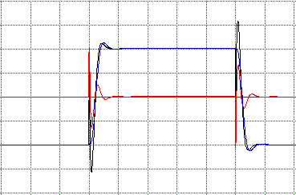

Figure 1. Square wave response of a 4th order Linkwitz/Riley crossover.
Blue = LP response, Red = HP response.

The summed response follows the initial tweeter rise then shows significant negative swing after which it generally follows the woofer response. This is a result of the frequency dependent group delay of the crossover. It can be argued as to the audibility of this temporal distortion, but its presence is clear. I chose the LR crossover for this example since the zero interdriver phase difference makes it an obvious and popular candidate for digital, linear phase crossovers based on HP and LP response that are themselves linear phase.

Since we will be addressing crossovers composed of linear phase LP and HP filters we begin by considering only the amplitude response. For simplicity I consider a low pass filter with amplitude response given as

____________
|LP| = 1/√((1-f^{n})² + f^{n}/Q²) (1)

where f is frequency normalized by the crossover frequency, f = ω/ω_{c}. This expression yields an amplitude response with an n^{th} order roll off and a response with magnitude
20 Log(Q) at f = 1.0. For n equal to 2 the amplitude given be Eq(1) is consistent with that of any standard 2nd order filter, Butterworth, Bessel or Linkwitz/Riley, for example. For n greater than 2 the response is only consistent with symmetric higher order filters. These include Butterworth filters (n even or odd, Q = 0.707) and Linkwitz/Riley filter (n even, Q = 0.5), but not higher order Bessel filters. The corresponding HP filter amplitude is
____________
|HP| = f^{n} /√((1-f^{n})² + f^{n}/Q²) (2)

Thus a linear phase filter with amplitude given by Eq(1) or (2) can be expressed as

T(f) = M exp(-icf) (3)
_
where M is the magnitude given by either Eq(2) or (3), c is a constant, and i = √-1. The phase of T(f) is

Φ(f) = -cf (4)

and is therefore a linear function of frequency. C represents a constant time delay and for the sake of argument can be taken as arbitrary, ≥0. Since a pure time delay does not introduce any time domain distortion, an HP, LP pair of linear phase filters with phase distribution based on the same value of c will provide transient perfect response, provided the summed amplitude of the HP and LP filters is flat. Since these filters will have the same phase response the interdriver phase difference will be zero. Thus the obvious choice for the amplitude response is the LR amplitude. Figure 2 shows the square wave response for a 4th order linear phase crossover with LR4 amplitude. One important

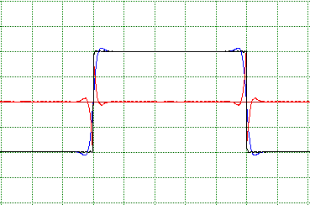

Figure 2. Square wave response of a linear phase 4th order crossover
with Linkwitz/Riley amplitude response. Blue = LP response,
Red = HP response.

observation is that we see a small degree of ringing in the individual LP and HP responses. This ringing will increase with higher order amplitude responses but on axis the HP and LP ringing cancels to sum to a perfect square wave output. Any order LR amplitude response can be used to form symmetric linear phase filters. In fact, even odd order LR type filters can be constructed. It has been suggested that the pre-ringing may be an audible artifact in the off axis response and may color the sound. However, while not pre-ringing, the ringing of the standard LR4 crossover and the transient distortion is obviously greater in magnitude and doesn’t cancel on axis, let alone off axis. Thus which the effects are audible and which are worse must be left to the auditioner to decide. These issues are not clear cut.

As stated above, the LR family of amplitude responses provides obvious choices for use in linear phase crossovers since they sum flat with zero interdriver phase difference. However they are not unique. We can use any linear phase response to derive a complimentary HP section following the subtractive technique of Lipshitz and Vanderkooy [2]:

T_{HP} = exp(-icf) - T_{LP} (5)

where exp(-icf) represents a pure time delay and is exactly the same as the delay (or DC group delay) associated with the linear phase LP response, T_{LP}. In fact, T_{LP} need not even be a linear phase response. Assuming that T_{LP} is linear phase for the moment we may write, for example,

T_{HP} = exp(-icf) - M exp(-icf) (6)

where M is the magnitude of the LP filter given by Eq(1). We can factor Eq(6) as

T_{HP} = exp(-icf) (1- M) (7)

Form Eq(7) we see that the magnitude of the HP filter will be given as
____________ ___________
(1-M) = ( √(1-f^{n})² + f^{n}/Q² - 1 ) / √(1-f^{n})² + f^{n}/Q²
______________ ______________
= ( √(1-2f^{n} +f^{2n} + f^{n}/Q² - 1 ) / √(1-2f^{n} +f^{2n} + f^{n}/Q² (8)

Setting Q = 0.5 we find
___________
(1-M) = f^{n} /√((1-f^{n})² + 4f^{n}) (9)

which is just Eq(2) with Q = 0.5. This result is expected as we already know that the magnitude of the complimentary HP filter to a linear phase LP filter with LR amplitude has the LR magnitude of the same order. But what if something other than an LR LP amplitude response is chosen to define the LP filter? For the most part we get varied HP responses depending on the value chosen for Q in the LP response. Examining the numerator of Eq(8), we can examine where it is equal to zero, or where the square root term equals 1.0. For this to occur

2f^{n} = f^{2n} + f^{n}/Q² (10)

Assuming that f ≠ 0 this reduces to

f^{n} = 2 – 1/ Q² (11)

From this we see that for Q < 0.707, f^{n} will be less than zero. This means that for real, positive frequencies the response will roll off smoothly with an n^{th} order slope. We also note that for Q < 0.707 the magnitude of the LP filter response, M, is monotonic and M ≤1.0 for all f. Thus, from Eq(7) the phase of the HP section will remain -cf. For Q > 0.707 we find that f^{n} will take on positive values. This means that the amplitude will have a zero or a null will be present somewhere in the stop or pass band and the response will have a notched behavior. This null will occur where the LP amplitude = 1.0. For Q = 1 the null will occur at f = 1. Larger values of Q will place the null above f = 1. For 0.707<Q<1 the null will occur between 0<f<1. Below the null frequency, when Q > 0.707 the LP filter amplitude exceeds unity. Thus the quantity, (1–M), will be negative. Now the magnitude of the response can not be negative and the implication of this is that the phase of the HP sections will discontinuously jump by 180 degrees below the null frequency. The summed response will, however, remain linear phase. Below the null frequency the response will again roll off n^{th} order. When Q = 0.707, Eq (10) is satisfied only for f = 0.

An example of applying Eq(7) base on a 4th order LP response with Q = 0.25 and corner frequency of 2 k Hz is shown in Figure 3. We can see that while the LP response with Q=0.25 has an amplitude of -12 dB at its corner frequency, 2 k Hz, the actual crossover point is at 1350 Hz where the response is -6dB for both the HP and LP sections as it must be since both filters have the same phase and zero interdriver phase difference. The black curves are for a 4th order LR crossover at 1350 Hz and are shown

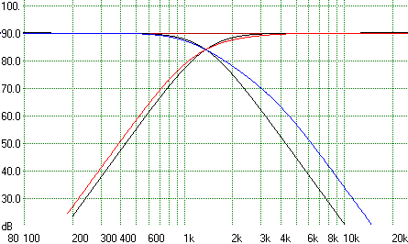

Figure 3. Subtractive derived linear phase crossover filters based on a
Q = 0.25, 2 k Hz LP magnitude. Actual crossover point is 1350 Hz.
Black curves are 4th order LR at 1350 Hz for comparison.

for comparison. The 4th order roll offs of the linear phase crossover filters is apparent.

When the LP section Q is greater than 0.707 a notched response is obtained for the HP section. An example for a 4th order LP response with Q = 1.0 and corner frequency of 2 k Hz is shown in Figure 4. Note that the ultimate roll off of the HP section is 4th order, the same order as the base LP response roll off and the null is at 2 K Hz.

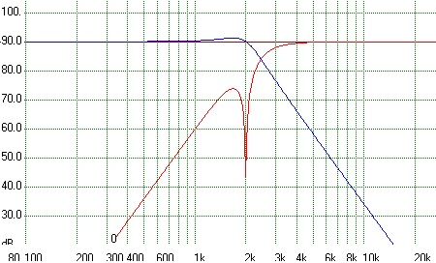

Figure 4. Subtractive derived linear phase crossover filters based on a
Q = 1.0, 2 k Hz LP magnitude. Actual crossover point is 2450 Hz.

Figure 1-4 show the basic differences between the characteristics of a true, minimum phase LR4 crossover and crossovers based on linear phase filters which have symmetric, LR type amplitude responses and asymmetric amplitude responses based on the subtractive delayed approach where the base LP filter was linear phase. Provided that Q of the LP section is less than 0.707 the HP section of the asymmetric crossover was found to also be linear phase. These linear phase crossovers all exhibit the characteristic ringing of the HP and LP sections, as shown for the linear phase, symmetric crossover in Figure 2. But what happens if we follow the original Lipshitz and Vanderkooy subtractive approach where the LP filter is a minimum phase filter? Figure 5 shows the result for a subtractive delayed crossover for which the base LP filter has an LR6 minimum phase response. As we see the HP section, in red, rolls off at only 3rd order. The black curve is the LR6 HP amplitude presented for comparison. This 3rd order slope is the steepest, monotonic HP slope we can obtain without resorting to the truncated exponential LP filter [2]. At the crossover point the amplitude response is down by less than 6 dB. This indicates that the interdriver phase difference is not zero. The interdriver phase difference in the crossover region is about 65 degrees, thus the vertical polar response for this crossover is not particularly good. The TE3 LP yields a HP with 4th order roll off, but at a further degradation of the vertical polar response since the interdriver phase difference is about 90 degrees.

The square wave response of the crossover from Figure 5 is shown in Figure 6. Compared to Figure 2 we see that there is no preringing. The LP response (blue) shows a smooth rise, typical of a minimum phase LP filter, with some ringing as it approaches the maximum amplitude. This is the response we expect for a standard, minimum phase LR6 LP filter and is similar to that of the LR4 LP filter response shown in Figure 1. However, by comparison to the response shown in Figure 1, the HP section does not exhibit the large initial positive spike followed by the decay. Rather the tweeter initially shows a negative spike. This is not preringing, but simply the required response to cancel fall in the LP response. The summed response, in black, is a perfect square wave.

It appears that the LP and HP filters actually respond before the input changes level when we look at the square wave response. However, this is not the case. We must recall that the output is delayed, thus the input signal actually switches at the point where the tweeter response begins to go negative. Thus, Figure 6 shows that when we substitute a minimum phase LP filter for a linear phase LP filter in the subtractive delay construction we eliminate the preringing associated with the linear phase LP filter although we do sacrifice the zero interdriver phase difference and degrade the vertical polar response.

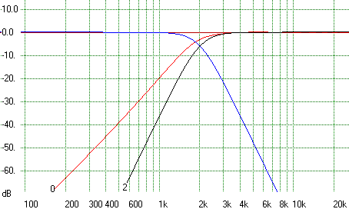

Figure 5. Subtractive derived linear phase crossover filters based on a
minimum phase LR6 LP filter response. The HP roll off is
only 3rd order.

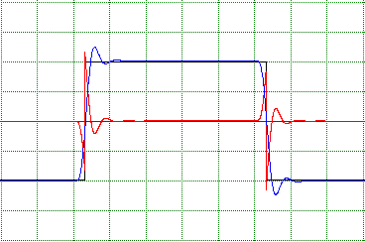

Figure 6. Square wave response for the crossover shown in Figure 5.
The characteristics of the Lipshitz-Vanderkooy approach can be improved upon by using a higher order Bessel LP filter for the base response. The Bessel LP filter has the benefit that it yields nearly ideal impulse response and has maximally flat group delay. The amplitude of a subtractive delayed crossover based on a 6th order Bessel LP filter is shown in Figure 7. The LP section is constructed so that the phase is -270 degrees at 2 k Hz. The nominal crossover point is 1650 Hz. The black curve is an LR2 response for comparative purposes. As can been seen the response is -6 dB at the crossover point indicating zero interdriver phase difference in the crossover region. Thus this crossover will have excellent vertical polar response. However, we observe that the HP roll off has now been reduced to 2nd order. This is true of all Bessel based subtractive delayed

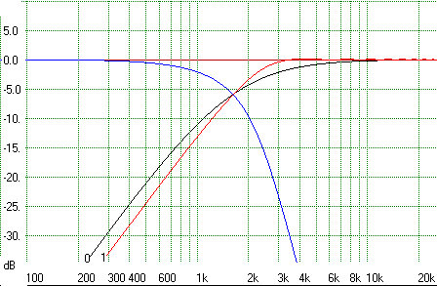

Figure 7. Subtractive derived linear phase crossover filters based on a
minimum phase 6th order Bessel LP filter response. The HP
roll off is only 2rd order.

crossovers regardless of the order of the LP filter. We have sacrificed roll off rate in the HP section for improved polar response. Finally, the square wave response of the Bessel based crossover is shown in Figure 8. The key observation here is that there is nearly a complete absence of ringing in either the HP or LP response. Thus, while we have given up HP roll off rate we have achieved improved transient response of each filter section and excellent polar response. Note the significant improvement in the square wave response compared to the response shown in Figure 2 where the HP and LP filters were linear phase with LR4 amplitude responses.

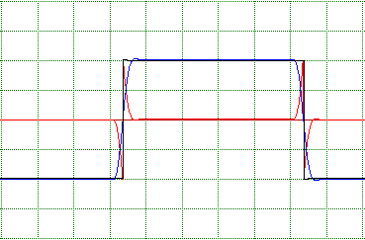

Figure 8. Square wave response for the crossover shown in Figure 7.

A New Asymmetric Linear Phase Crossover with High Order HP Response

Earlier I discussed the response of subtractive delayed, linear phase crossovers based on linear phase LP filters with amplitude function given by Eq(1) for Q other than the LR value of 0.5. I have intentionally delayed discussing the characteristic of the HP response when the chosen LP response has Q = 0.707 because this is a very special case. First, when Q = 0.707 the HP response is given as
______ ______
(1-M) = (√ 1 + f^{2n} - 1 ) / √ 1 + f^{2n} (12)
______ ______
We can multiply Eq (12) by (√ 1 + f^{2n} + 1 ) / (√ 1 + f^{2n} + 1) = 1.0 with the result
______
(1-M) = f^{2n} / (1 + √ 1 + f^{2n} + f^{2n}) (13)

Eq(13) is the expression for the amplitude of the HP section when the LP section has Q = 0.707. We note that the numerator of Eq(13), which controls the roll off rate, is order 2n from which we can see that the asymptotic roll off rate is twice the n^{th} order roll off rate of the base LP section. Thus for an LP response with Q = 0.707 we can generate asymmetric, linear phase crossovers in which the HP section rolls off twice as fast as the LP section. Such a response based on a 4th order, Q= 0.707, 2 k Hz LP response is shown in Figure 9. The 8th order roll off of the HP section is clearly evident. It should also be noted that if the HP filter, as defined by Eq(2), is used as the base filter in the subtractive development of an LP filter, the LP filter characteristics are similar. That is, for a HP filter with Q = 0.707 the LP sections will roll off at twice the HP rate. This is of less significance since we are generally interested in crossovers that provide greater tweeter protection.

The square wave response of such a crossover is shown in Figure 10. For comparison the square wave response of a symmetric 8th order linear phase crossover is shown in Figure 11. The HP and LP sections of the crossover of Figure 11 both have LR8 amplitude responses. While difficult to see on the scale of the figures, the ringing of the

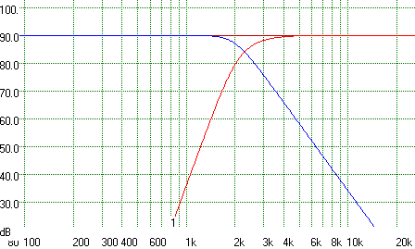

Figure 9. Subtractive derived linear phase crossover filters based on a
Q = 0.707, 2 k Hz LP magnitude. Actual crossover point is
2390 Hz.

asymmetric crossover (Figure 10) is slightly less severe than that of the LR8 based symmetric crossover (Figure 11). The asymmetric crossover also yields superior tweeter protection since its HP response is down10dB at 2 k Hz where as the LR8 crossover is down only 6dB.

Finally the vertical polar response of the asymmetric linear phase crossover of Figure 9 is shown in Figure 12 at the crossover frequency. Even though the response is asymmetric, the linear phase nature of the response and the steep roll off rates result is a nearly perfectly symmetric polar response.

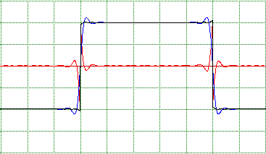

Figure 10. Square wave response of asymmetric linear phase crossover
based on a 4th order LP response with Q = 0.707.

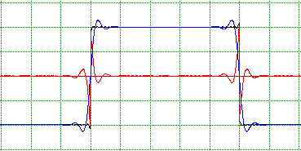

Figure 11. Square wave response of symmetric linear phase crossover
based on a 8th order LR amplitude responses.

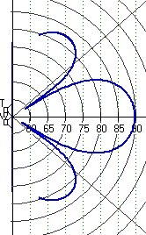

Figure 12. Vertical polar response of the crossover depicted in Figure 9.

Clearly there are many other and interesting possibilities to generating linear phase crossovers. However the combination of excellent polar and perfect transient response characteristics of the asymmetric crossovers developed by subtractive methods using minimum phase, higher order Bessel LP filters make them very attractive in suitable applications. Asymmetric subtractive delayed crossovers based on linear phase LP sections with amplitude responses corresponding to Butterworth (Q = 0.707) alignments are also worthy of consideration due to the higher order roll off of the HP sections. This allows the use of lower order LP sections which help reduce the preringing that is associated the questionably audible artifacts with the in such filters. In particular, use of 2nd order Butterworth amplitude response for the LP section will minimize preringing. These filters, while reducing these artifacts, also provide 4th order tweeter protection and retain excellent vertical polar response.

The origin of preringing in linear phase filters

In the preceding discussion we have observed preringing in the linear phase filters that is absent from their minimum phase counter parts. This is often though to be an undesirable attribute of linear phase filters. The preringing becomes more severe with increasing filter order. But where does it come from? The answer is really quite simple. Figure 13 shows a comparison of the reproduction of a 100 Hz square wave by a 4th and 24th order LP linear phase 2 k Hz filter. Note that both responses show ringing at the

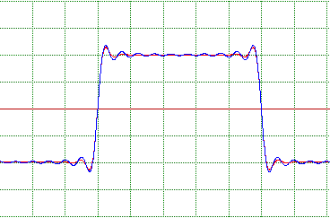

Figure 13. Reproduction of a 100 Hz square wave by a 4th (red)
and 24th (blue) order, 2 k Hz, linear phase LP filters.

same frequencies, but with different magnitude. The lower order filter appears to ring less than the higher order filter. But what is really happening? First we recognize that a square wave can be expressed, using Fourier series analysis, as the infinite sum of a series of sine waves

SW = sin(x) + sin(3x)/3 + sin (5x)/ 5 + .....
_{∞,2}
= ∑ (1/n)sin(nx) (15)
^{n=1}
Thus a square wave is composed of the fundamental frequency of the wave plus the sum of all the odd harmonics, out to infinity, with ever decreasing amplitude. For the square wave to be correctly reproduced we require 3 things: 1) all the frequency components must be present, 2) the amplitude of each component must be reproduced correctly, and 3) the phase relationships between the different frequency components must be preserved. Since we are dealing with linear phase or constant time delay filters, the third requirement is satisfied by default. However, when we pass the square wave through our LP filter the amplitude of the frequency components above the filter cut off point are not reproduced with the correct amplitude; they are attenuated. For two filters with the same cut off point but different attenuation rates, the same range of frequency components are attenuated but the components are attenuated differently. With a so called brick wall LP filter the square wave Fourier series is simply truncated above the cutoff frequency. In a sense, these attenuated or truncated frequencies are missing from the reproduction of the square wave. Depending on the level of attenuation, some are missing more than others, so to speak. But the point is that when higher frequency components are missing, or reproduced with the incorrect amplitude, as they are after filtering the signal with an LP filter, the square wave appears as shown in Figure 13. The pre/post ringing is not some undesirable artifact of the linear phase filter, but rather a true and accurate result of removing high frequency components from the input signal, that is, it is the truncated representation of the square wave. In Figure 13 where a 100 Hz square wave is considered, the frequencies above 2 k Hz are attenuated by different degrees, depending on the filter order, resulting in the difference in the amplitude of the ringing. Since the higher order filter attenuates the frequencies just above the cut off point more, ringing at these frequencies is more evident in the higher order filter.

References

- R. H. Small, “Constant-Voltage Crossover Network Design”, J. Audio Eng. Soc. vol. 19, no.1, p 12, Jan. 1971.
- S. P. Lipshitz and J. Vanderkooy, “A Family of Linear-Phase Crossover Networks of High Slope Derived by Time Delay”, J. Audio Eng. Soc. vol. 31, no.1/2, p 2, Jan. 1983.
- J. P. Kreskovsky, “A Transient-Perfect Second-Order Passive Crossover”, audioXpress, vol. 32, no. 5, p 22, 2001.
- J. P. Kreskovsky, “Design an Active Transient-Perfect Second-Order Crossover”, audioXpress, vol. 33, no. 12, p 22, 2002.
- E. BÆkgaard,”A Novel Approach to Linear Phase Loudspeakers Using Passive Crossover Networks”, J. Audio Eng. Soc. vol.25, no. 5, p284, Ma7 1977.
- J. P. Kreskovsky, “Generalized Filler Driver, 3-way, Transient Perfect Crossovers”, Web Publication, January, 2002.
- J. P. Kreskovsky, “Subtractive Delay, Transient Perfect Higher Order Crossover Excel based CAD Tool”, Web Publication, October, 2002.

