Frequency Divider by one transistor BC549
Date: 2012-8-29Author: anonymousReading(1364)Collection this page
This circuit designs to upward for divide by the frequency of a signal input , give down left just the half then to export come to the way output. Because of the transistor Q1 (BC549) bias stay the condition not active it then active get especial while signal input be positive volt only. This circuit modifies from oscillator model colpitts , Tank Circuit that compose L1,C4 and C5 can fine about 16.5 kHz. When get a signal input 30-60kHz the circuit lock and oscillator Generator in 15-30kHz frequency detail other sections , please see in the circuit be lucky yes.
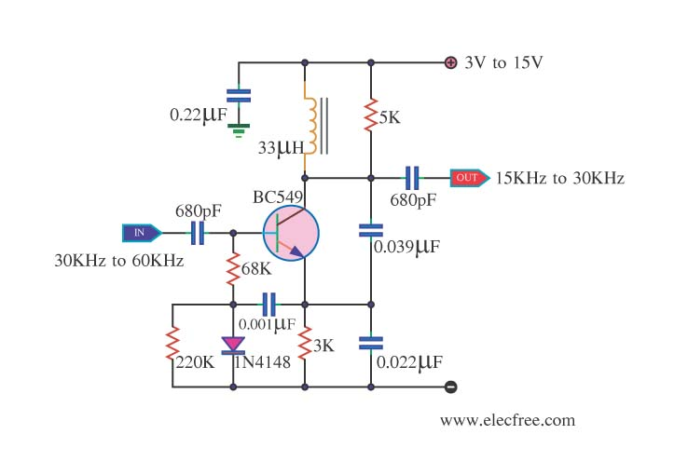
Related Links
More circuit about Frequency Divider
More circuit by BC549
circuit 4013 Divide by 2
circuit 4027 divide by 2 counter
circuit 4027 divide by 3 counte
Reprinted Url Of This Article:
http://www.eleccircuit.com/frequency-divider-by-one-transistor-bc549/
Declaration
We aim to transmit more information by carrying articles .Please send us an E-mail to wanghuali@hqew.net within 15 days if we are involved in the problems of article content ,copyright or other problems. We will delete it soon .
More information about:bc549 frequency divider
Tags:bc549 frequency divider

One-stage frequency divider
Rating: 0.00 / 10
Inside:
Repository
visit page.
