----------------------,---------------1
1 1. Input Amplifier 1
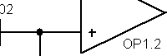
'l _ '

--------------------------------
: 3
I C401 (fJF) =_::
1 Fmin (Hz)
I
,-------------------,-----------------------------------1
5. Low Pass- Krossower :

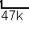
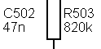
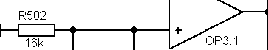
'

I

in L
C101

'-_

C105 (nF)
700
---":.:_
R107 (kOm)
C401
0 681J

pm 0 OP2 1

---------

in R
C102
C105 +

'- -
,---{R=50:::1:::t-<=PJ-50_1_10---+{=

HiL C103
-
1k u jg

47k
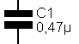

:m;-

'- -
9-+---e +,---+---{_ Gnd

+----- ' '
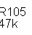

+
Hi L 1
'
: 4. Volume :

'

,----------------------------------,--------------,
: : 6. Phase switch
I L _

'
'
' R601

--,

---------------------------- --

-----------1

+
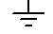

i,:
> j

2

3. Filtr

Linkwitz Transformator for subwoofer

by AudioKiller

: 2. Subsonic :
'------------------- ----------
L---------------------- --------------

http://www.electroclub.info

