Hybrid amplifier using a 5687 tube,
a Lundahl interstage transformer
and Magnatec PowerMosFets

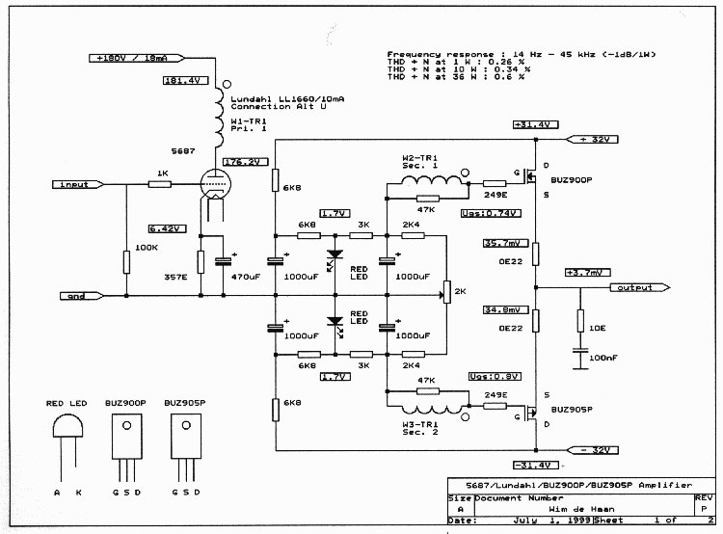

Most credit goes to Guido Tent, this for his 'innovative' thinking.

This amplifier project was published in the Electronics World + Wireless World (EWWW) March 2000 issue and in the Glass Audio (TAA) no.5 2000 issue.
Notice : This following article was originally written in Dutch and is translated using Word Translator '98®.
A hybrid amplifier revisited.
In my thoughts I had already built four hybrid amplifiers, however it never came to the point to build one. Begin this year I finally started with the development of this amp and the try out of my own hybrid amplifier. This hybrid amplifier uses a 5687 tube, SCR coupling capacitors and Magnatec PowerMosFets. Result is extraordinary good. My Dynaudio loud speaker (10.5 litre basreflex, 17W75XL04 mid / low unit and a T330D Esotar unit) is really in love with this amplifier. Music like 'Get Here' by Oletta Adams and Neil Young's 'Cortez the killer' of the live 'Weld' cd are phenomenal. An other good example is jazz guitarist John Scofield with 'Dark blue' (Hand Jive cd). Besides that is my favorite classical piano music and my favourite music of jazz pianist Keith Jarrett reproduced in an extraordinary good way. I can state that the amplifier understands my music choice. So no reason to try another design. However after reading an article by Guido Tent (Audio & Techniek No. 69 May / June 1999), it started to itch to try out this idea. His idea inspired me, because old schematics with currently obtainable components like transformers and semiconductors can lead to the required result. In the 30's and 40's many, many amplifiers were built with interstage transformers, also in the sixties they used interstage transformers in transistor amplifiers. In a Japanese magazine from 1995 I did found a design with an opamp, an interstage transformer and two N-PowerMosFets.
After reading about the article I had still some questions toward an design like this. An transformer? This component was in the past with great satisfaction eliminated? However the 'disappearance' of the couplingcapacitors and the unique nature of the design has been my motivation to build this amplifier.
I have chosen for the following configuration. An 5687 tube, an Lundahl interstage transformer and Magnatec PowerMosFets. Because I had an number of 5687's tubes and because I have used the 5687 in my former hybrid (and this successfully), have I chosen for this tube. The Magnatec PowerMosFets are chosen this because I already used them in other projects and this also with good results. This PowerMosFets are special made for audio and are reasonable priced ($ 17.50 each). The BUZ 900 has a TO-3 case and the BUZ 900P an TO-247. Also is there an version with two N-MosFets parallel in one case (and of course an version with P-MosFets, the BUZ900DP and the BUZ905DP), besides those Magnatec manufactures a N and P PowerMosFet in one (!) case (the MAG90X95). And what to think of the 500W version in an SOT-227 case. Now was the problem which interstage transformer. The interstage transformers of Tango and Tamura are simply to expensive for an 'try out' like this. After an period surfing on the internet the choice was not difficult. An interstage of Lundahl was the best choice, this on behalf of the good specifications, obtainability and the price. The Lundahl have been ordered in Belgium, and were deliverable from stock. After receiving the transformers, I started quickly with the construction of an prototype. In the mean time emailed with Guido, not only about the hybrid but also about the well and woe of the DIYers in The Netherlands in general. I had also the opportunity to ask him about the in Audio & Techniek forgotten schematic. He was so friendly to send me this. It is skillful if you have already an begin of the possibility. In the enclosed Orcad drawing you can find the schematic as used / build / tested by me.
The original schematic is only put on 'paper' and is not actually build, with result that is not noticed that the LEDs incorrect were pictured and that one of the junctions of the secondary winding was wrong pictured. Building my amplifier I noticed that my design did oscillate and for this reason an RC network is placed. An other solution to eliminate the oscillation is to change the gate resistor from 249E to1K5. The signal didn't change. The secondary winding of the Lundahl has the thing that if unloaded an peak of 8 dB will occur at 30 kHz. With a resistor of 47K parallel to the secondary winding the best result is reached between distortion and damping / frequency response. The amplifier has now a peak of a 0.5 dB at 20 kHz. Further it is progress is straight with the -1 dB point on 14 Hz and 45 kHz, what can be called an achievement for an 1:1+1 transformer. An effort to with an RC network parallel to improve the damping of the secondary winding, had no success.
This all applies to the used Lundahl 1:1+1 interstage of the type LL1660. This trannie is obtainable in three various versions namely: a push-pull version, a single-ended 18 mA version and a single-ended 10mA version. I have chosen for the LL1660/10mA. This interstage is wired according the connection alternative Alt U. Chosen configuration is suitable for use of single-ended to push-pull and a primary current of 20mA. The 5687 is suitable to be used with this current. An alternative choice can be an interstage transformer of Border Patrol. This English company manufactures also an usable 1:1+1 interstage. Part number of this transformer is ITPP-860. I mention this company only, I have no experience with this product.
On this moment not everything can be told about the sound / music quality, this because I have built only one prototype (so one channel). But in mono it sounds promising. Noticeable is the good audibility and clearness of the sound. The low end is dry, punchy and tight. Although mono, the music of Keith Jarrett fascinated me. In brief, I have to build the second channel very quickly. The stereo and final version is not yet made, because I'm still in doubt whether I will try the amplifier with two N-PowerMosFets yes or no. If I will, you will receive an update from me. I hope to start at short notice with the circuit boards and construction of this amp using a trannie.
Wim de Haan
Reference : Guido Tent (A&T No.69 May / June 1999 page. 38)
* More information on my hybrid amplifier: http://www.homestead.com/whaan/files/index.html
* Music lovers of classical piano music might visit: http://www.wdehaan.demon.nl/
* Information on Lundahl transformers (datasheets):
Internet : http://www.lundahl.se/
Telephone : + 46 176 13930
* Info on Magnatec PowerMosFets (datasheets):
Internet : http://www.semelab.co.uk/magnatec.htm
Telephone : + 44 1455 554711
* Info . Border Patrol transformers:
Internet :
Telephone : + 44 1273 276716
* Info . Lundahl Belgium:
Internet : http://www.degryse.com/
Telephone: + 32 3 281 32 44

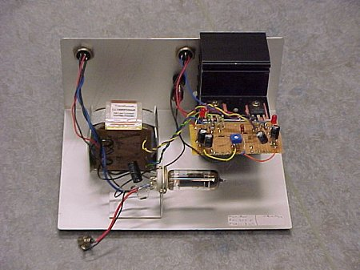
Prototype amplifier using a 7044 tube

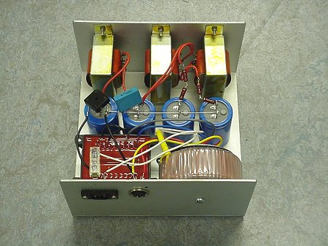
Prototype high voltage powersupply using 3 chokes

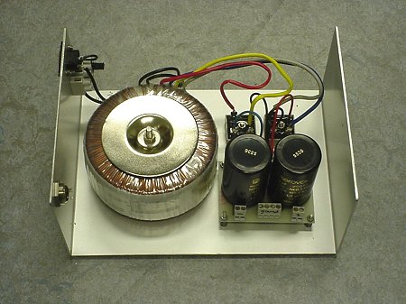
Prototype low voltage powersupply using a 300 VA transformer and BHC SlitFoil capacitors

Test results hybrid amplfier using the Lundahl LL1660/10mA interstage transformer

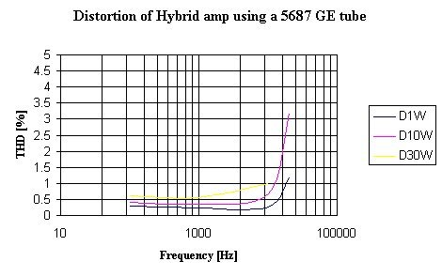
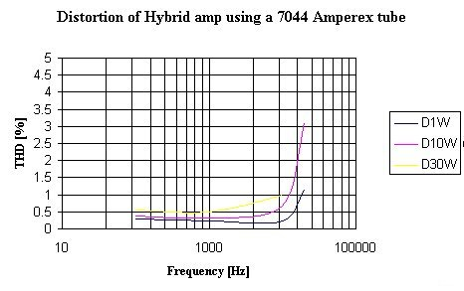

5687 tube  General Electric | distortion at 1 W | distortion at 10 W | distortion at 30 W | power at  1 % distortion
100 Hz | 0.28 % | 0.4 % | 0.62 % | 41.4 W
1 kHz | 0.24 % | 0.34 % | 0.56 % | 42.3 W
10 kHz | 0.25 % | 0.68 % | 1.0 % | 30 W
20 kHz | 1.2 % | 3.2 %

7044 tube  Amperex | distortion at 1 W | distortion at 10 W | distortion at 30 W | power at  1 % distortion
100 Hz | 0.28 % | 0.38 % | 0.56 % | 40.0 W
1 kHz | 0.24 % | 0.33 % | 0.49 % | 41.0 W
10 kHz | 0.24 % | 0.66 % | 1.0 % | 30 W
20 kHz | 1.15 % | 3.1 %

Frequency response at 1 W / - 1 dB with regard to 1 kHz | Plate current 18 mA | 23 Hz ..... 45 kHz
Frequency response at 1 W / - 1 dB with regard to 1 kHz | Plate current 20 mA | 19.7 Hz ..... 45 kHz

20 kHz: + 0.5 dB | 25 kHz: + 0.75 dB | 30 kHz: + 1 dB
35 kHz: + 1.5 dB | 37 kHz: + 1.75 dB | 40 kHz: + 0.5 dB

Input voltage for 40 W output at 8 ohm - 1kHz | 1.25 Veff

 | damping factor 8 ohm
100 Hz | 6.0
1 kHz | 6.8

DC voltage MosFet circuit | +/- 31.4 V
Current per MosFet | 160 mA
DC voltage 5687 General Electric circuit  Cathode voltage 5687 General Electric | + 181.4 V  + 6.42 V (Ia=18 mA)
DC voltage 5687 General Electric circuit  Cathode voltage 5687 General Electric | + 195 V  + 7.1 V (Ia=20 mA)
DC voltage 7044 Amperex  Cathode voltage 7044 Amperex | + 187.3 V  + 6.25 V

