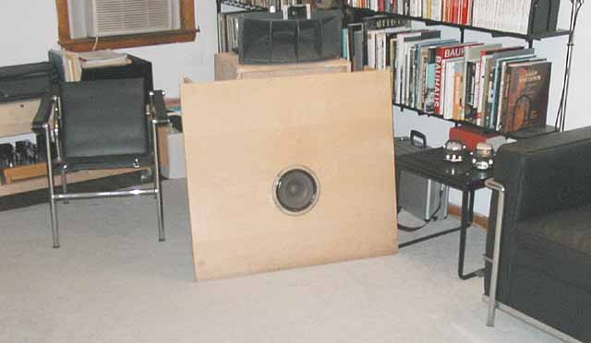
Open Baffle
the minimalist approach

After building my first SE 300B amp in the mid 90s, I embarked on a search for more efficient speakers to replace my Spendor LS3/5A. I had just purchased a pair of Altec 755Cs at an Audiomart Show and was looking for a suitable enclosure for the unit. Fortunately I came across an open baffle article in Stereo Sound "Tube Kingdom", Volume 3, 1996. I don't read Japanese but these magazines (like MJ) have detailed pictures where I get a lot of ideas for projects. The article was a "shootout" of 8" full range and coaxial drivers - Altec/WE755A, Altec 755C and 755E, Altec 409B and 409-8E, JBL LE8T-H, EV Pro-8A, as well as 15" coaxials- Altec 604-8K and JBL 2155H.
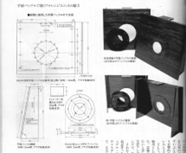
Click on image to zoom or print
The Stereo Sound plan was in metric and used a material similar to a butcher block around 3/4" thick. It was designed to take adapter plates so that an 8" or 15" driver can be mounted on the same baffle. Knowing that such material will cost a lot of money and hard to procure, I decided that the easiest way to build my baffle was to convert the dimensions to inches and make a quick trip to the lumber yard for 3/4" baltic birch plywood pieces cut to size so that I can start listening. Here is my version of the Open Baffle. For more building tips, check out my homebrewer article [pdf].
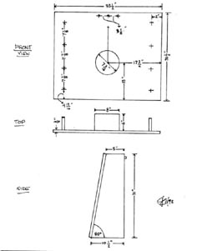
Click on images to zoom or print
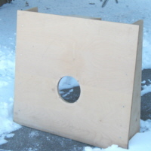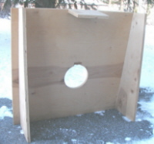
Around the same time I embarked on this project, my friend Ding acquired a pair of Altec 604-8G and was also looking for a suitable cabinet. I immediately faxed the plan to his office and that same weekend he called stating that it was a success. This is the result of his weekend's effort and he still uses the same configuration after trying a couple of bass reflex cabinets through the ensuing years. Likewise two of my SETUP friends have so far found no reason to experiment further with enclosures.
I later found the June 1996 Hi-Fi News and record reviews, "Classic Hifi Supplement" issue which reprinted a November 1956 review of the Wharfedale SFB/3 designed by G.A Briggs. This baffle has almost exactly the same dimensions as the Stereo Sound version, which also shared the proportion of the original Quad ESL57, another favorite speaker from my PP amp days. Brigg's approach was to use thinner sheets of plywood "sandfilled" in between for the baffle and utilized a 3-way configuration using 12" and 10" drivers with a 3" cone tweeter mounted on the rear top plate firing upwards.
Wharfedale SFB3
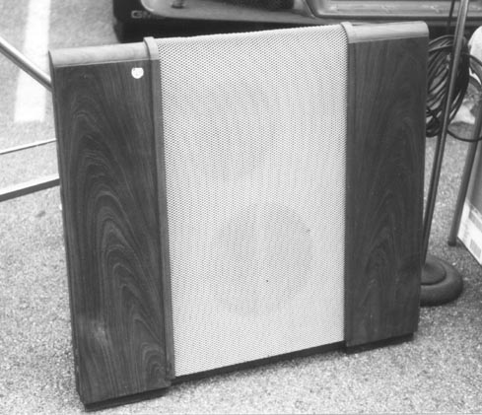
There must be something behind the dimensions [golden mean, perhaps?] that make it work. Of course one cannot expect ultimate bass extension with an open baffle but the lack of cabinet colorations gives purity to the sound that many will find very appealing.
It won't cost much and not too difficult to build so give it a try with your favorite driver.

FAQs about the OB plan:
"Form follows function"
1. Materials [acrylic, plexiglass, MDF and etc.] - visitors to this site are already familiar with my adversity towards "dead sounding" synthetic components. Solid wood or edge glue butcher block type material will probably give the best sonic quality. I endorse 3/4" plywood because that is the material I use and very satisfied with the sonic results and have no further desire of upgrading. Besides it is cheap and if you like what you hear and decide to experiment with your own exotic materials later not much is lost with the initial investment.
2. Driver off set - I have read in various reference materials on audio that off setting the mounting position [slightly off center] of the driver can further reduce cancellation. I have not tried this because in the real world unless your cutting tool is aided by computer and laser devices, it is almost impossible to perfectly cut exactly at center. So I do not worry about it.
3. Driver mounting too low - common sense dictates that the reason why the baffle was tilted 80 degrees and mounted closer to the floor is to aid bass response. I tried lifting the OB a few inches off the floor and lost a substantial amount of weight in the lower frequency. Logically if one is to sit 1 meter away from the speakers the soundstage apparent would be a bit low. My listening position is almost 3 meters away and was never bothered by a "low soundstage". A good super tweeter can also aid in giving more height if your driver has limited HF extension.
4. Tall narrow baffle vs. wide and squat - I experimented before with approximate dimensions of 1.75' x 4.5 ' x 1/2" plywood to mimic a Magnepan SMGa style OB proportion and the driver mounted at ear level at the listening position. Potentially it looked good but the end result was; while it still had a pure midrange, it was quite a disappointment in terms of bass response. The priority here should be sound before aesthetics.
5. What's the purpose of the 6" x 8" top plate? This may look like an after thought but omit this from the design and you lose about 3 dB in bass response. The back legs and this top plate serve to further delay rear sound waves from reaching the front to soon which can result in bass cancellation.
6. Before sending an inquiry not answered above, please visit my speaker building tips page. Chances are your question will be answered there.

Visitors' Open Baffle
- Pictures and links to other JEL OB builders' sites

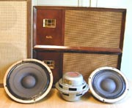
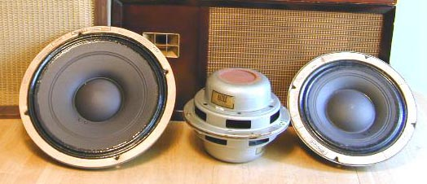
Here are a few drivers I have auditioned:
- 5"-6" - Radio Shack 40-1354 [5 1/4"], Pioneer PIM16 [back] [6", found inside old Lafayette SK124 speaker cabinets], Diatone PM610B.
- My favorite 8" drivers - WE or Altec 755A [cone detail], 755C [cone detail] and 755E [cone detail].
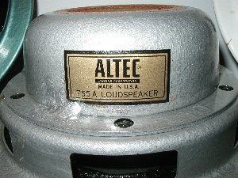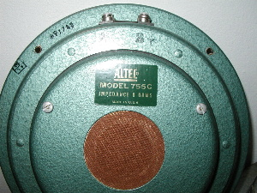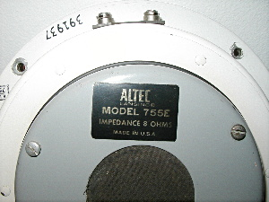
- Other 8" full range drivers - Altec 408 BiFlex, 400B, Jensen P8RX [back], P8RL + RP103, Stephens FR80, EV/University SP8B and SP8C [Radax series], Lafayette SK98 [back], Philips/Norelco 9710M
- 10" - WE/Altec 756 [back]
- 12" - WE/Altec 728B [back], Altec 601Duplex, 412 and 419A [back] series Bi-Flex.
- 15" co-ax - Altec 604B, 604-8G, 605, 602 Duplex, 415 and 420 BiFlex.
- Other possibilities include vintage units from Jensen (G610, H222, K210, and etc.), University, Electro Voice and others.
- You can also check out old paper cone drivers from tube type stereo consoles, and table radios or vintage Japanese drivers that came with compact systems. I'm sure there are many sleepers out there.
- I also did a "mini review" of drivers when I wrote my SP homebrewer article [pdf].
Open Baffle Links:
- Check out my survey of Altec 755 series.
- I highly recommend visiting Jiya's homepage for another perspective on open baffles using German drivers.
- Another Japanese site that contains a finely crafted open baffle design and check out his collection of vintage speakers.
Click here if you want to see my 2-way horn system and the Summer 2001 update or consider a Jensen compact 2-way.
Updated: , JE Labs all rights reserved

Back to Main Page or Shop Talk

