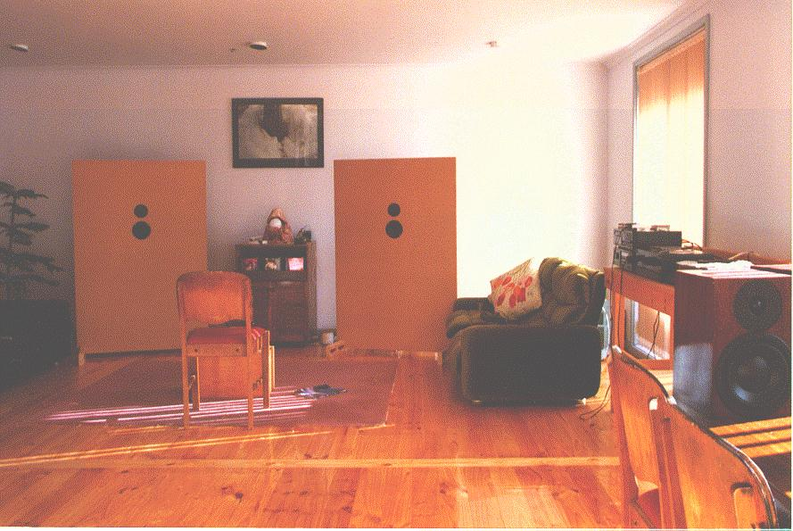
Here's a strange looking system I had along the way. It was a bit of an experiment into boxless speakers and dipole radiation. I think my wife must be VERY patient, EVEN I thought they looked UGLY! I built this system after hearing the lovely open sound of the Ambience ribbons at a local HiFi show. I was addicted to the dipole sound straight away.
The panels were 1500 by 1000mm pieces of 25mm MDF with a Vifa P13WG and D27TG35. The P13 radiated to the back as well as the front of the panel. They actually sounded very good. In retrospect I don't think I would aim for the 100Hz cutoff on these panels. 250-300Hz with a separate woofer for each channel would work well and also look much less intimidating. After a bit of use I added a second tweeter on the back of the panel. Although the first arrival from the speaker measured flat on the IMP, it did not sound flat. The room response showed a reduction in output above the 2200Hz crossover. The second tweeter brought up the top end to about the right level.
The system here uses a Dynaudio 30W54 subwoofer which is tucked behind the left panel. The sub was an unusual alignment, 70 litres tuned to 25 Hz. Try it on you're favorite box design program. This alignment offers low group delay and the 12dB/Octave rolloff matches the room nicely.
BTW, The speaker on the table is the satelite speaker to the system I built for my brother-in-law. It uses the Dynaudio 17W75XL and Vifa D27TG-35 tweeter. The box is 18mm MDF lined with expansion joint strip (tar soaked medite) with a layer of Sonex over that. The whole box is covered in a jarrah veneer which I french polished. This is teamed up with 2 Dynaudio 30W54's and around a kilowatt of amplifiers I built for him. The young lad is stoked!

