As clearly someone with an inclusive vision, for 2005 Shigeki Yamamoto attended the 11th Tokyo Tube Fair in the halls of the Akihabara casualty insurance once again with his own speakers [below]. He was showing the new YS-605P open-baffle model with a refurbished/modified 15" coaxial 16-ohm Altec 605A (or B) transducer that replaces his prior YS-604 reference speaker. That was driven by the A-08S amplifier. Shown as well was the new OS Series of modular equipment stands. From Yamamoto's show coverage notes, it appears that attendees were surprised to discover how 2 watts over appropriate speakers did not at all suggest audible limitations of any kind. This I can confirm from the other side of the world. From Taos, a check will shortly migrate eastwards. It'll prevent the A-08S from having to follow Elvis and vacate the premises. Where the latter's mortal shell broke down eventually, the former's inanimate circuit broke in. The subsequent transformation was a thing of beauty. It'll likely outlive all its owners like those blue suede shoes.
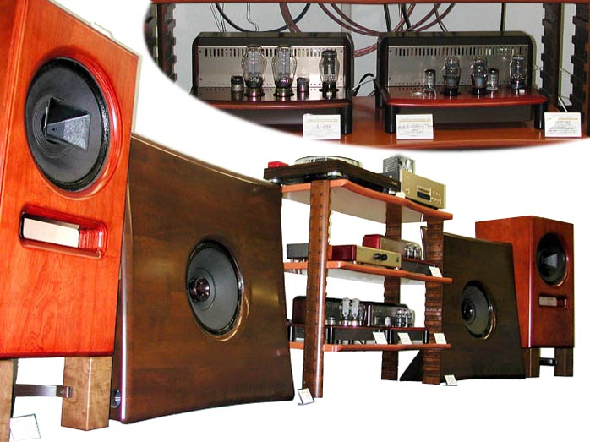
Here's a final outside observation (from owner Todd). It segues seamlessly into my own concluding listening impressions. He finds "that the Yamamoto sounds very natural with awesome tone and a very realistic bottom end. I would say that the Sun [Audio 2A3 amplifier] sounds more old school-tube euphonic and has a more metallic edge in the top and upper midrange, with a definitely rounder bottom compared to the Yamamoto." The A-08S is distinctly not old-school if by that term we mean the prototypical sound which most people still associate with valves - euphonic, forgiving, soft, pleasant but colored. The Yammy with the stock Cunninghams is new school ultra-modern. It obeys present-day expectations for resolution, speed and linearity, areas in which it completely transcends tubed preconceptions. It's fast, precise, with fully developed treble energy and incisive when called for. Here it acts all solid-statish if we must use another tired old label.
Most all transistor amps -- in my book at least -- match poorly with passive preamps. That's because passives don't complement the sand amps' lack of tone and treble sophistication with additive body or texture. The Yamamoto, however, cheerfully discards all crutches of active preamplification help. It's simply not a tonal cripple. It stands squarely on its own four feet. Solo, no assistance required or even desired. In fact, so uncannily endowed yet perfectly balanced is it that anything but the very best of active preamp circuits would compromise its transparency, speed and articulative precision. That self reliance opens doors to cost-effective super passives. Think the Music First Audio Passive Magnetic or the Audio Zone PRE-T1 (copper, not silver). Granted, their successful employ relies on sufficient gain elsewhere in the chain. Still, my experience suggests that conventional 2V-out sources and 100dB speaker efficiencies make passives perfectly suitable in average-sized living/listening rooms. Or else, consider a high-voltage source like the Audio Aero units which top out at 5V max.
The Yamamoto marries the sort of crystalline clarity we nowadays get from the best Class D amps. Then it offers the tonal substance and layered dimensionality those lack. This quality of modest wetness is instantly apparent. It's part of the good which tubes offer. Then the Yamamoto goes further than most of its valved brethren. It categorically avoids the many possible bads of tubes - thickness, blurring, softening, undue bloom and hooded frequency extremes. Think tone without the romantic glow or loose bloom. Think unfettered transient rise times without etchiness. The Canary Audio CA-308s with their 300Bs are slower, noisier, less precise, warmer, softer and fluffier. They're more romantic, less focused and clearly not as linear on the outskirts of the audible band (though not excessive anywhere and possibly simply a function of the 300B tube. Going to the Yamamoto, I had to dial the Definitions' bass attenuator down to compensate for the Yammy's higher amplitude response over the Canaries down low.)
Overall, that makes the Yamamoto leaner - or the Canary fatter, depending on where you perceive the center line. I would never call the Yammy lean per se. That tends to suggest a lack of body. There's body aplenty. It's simply not at the expense of incision, agility and velocity. Percussive events don't suffer blurring. Impacts exhibit neither blunting nor restraint. There's jump factor galore with this flea-powered amp. If the recording is bright and relentless, the Yamamoto will not exasperate it. But neither will it make excuses for the mastering engineer's failures. This type of honesty is what you expect from a highly resolved amplifier. It's also exactly what you get.
You could thus call the Yamamoto A-08S a device which is very close to the center of so-called neutrality. It's not tubey at all yet its use of glowing glass remains a distilled quality that is apparent in three areas: sculptural soundstaging effects; tone texture or fullness evenly spread across the audible spectrum; and projection power into the room. That last one is the hardest to quantify or explain. Yet it's arguably the most important aspect for listeners who expect a gripping encounter with their music. The most practical way to describe this quality is that it successfully undermines your audiophile hot-seat neurosis. Even sitting well off-axis where stereo effects break down and then disappear, the music remains fully involving. It communicates.
 |  | 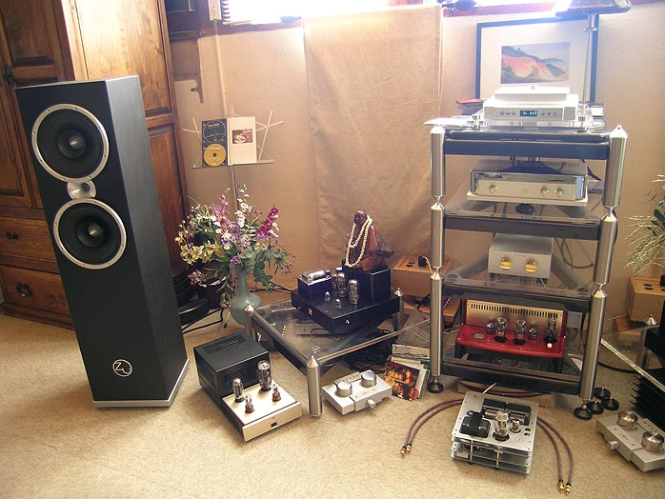
A superior orator dominates an auditorium regardless of where you sit in the audience. His presence telegraphs, period. Just so does the Yamamoto "charge" the musical particles to propel them towards you. Sounds esoteric and flowery? Sure - but it's no different than personal charisma or a strong biometric aura. People so endowed make their presence felt the moment they enter a room. It's a kind of biological electricity. Or call it audible silence. Or displacement pressure as though something invisible took up space. The Yamamoto has that too. Music played back over it takes up psychic space. True, many tube amps do the same. That's their special appeal after all.
However, most of them overlay the purity of such alluring power with patently obvious personality traits (colorations). They become less charming the longer you live with them. Eventually they begin to equalize on music's specialness. Then everything sounds the same. You'll ultimately tire of golden boys or girls. Remember Jude Law's charismatic character in The Talented Mister Ripley? And yes, he tired of our hero rather than the other way 'round. Still, it makes the point and, for a movie, ended up deliciously bloody. Should you feel inclined to refer to the Yamamoto as radiant -- I'm not -- you'd have to call it an impersonal radiance. Different recordings sound more rather than less different. That's always a sign of superior resolution and intrinsic neutrality. Put differently, the Yamamoto has precious little personality of its own.
A strategic contributor here is the astonishing S/N ratio. I strongly believe that so-called tube-induced noise is a convenient excuse for inferior engineering chops (or shoddy execution or sub-par parts). Nobody accepts noise in transistor amps. Why then in valved circuits? Eduardo de Lima's Audiopax Model 88 amps and Roger Hebert's Wyetech Labs Sapphire monos have previously proven their mettle on my 103dB Avantgarde Duos. The designer of the $3,000 A-08S now joins those other designers who plainly know how to make tubes operate in a noiseless environment. If you accept anything noisier, be prepared to call it a flawed design. While today's amp and those others mentioned in the same breath appear to be exceptions to the rule, they also prove that it can be done. Why settle for less?
 | 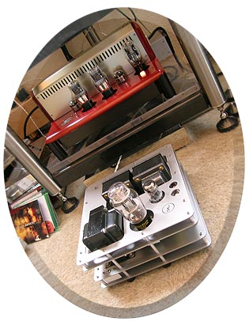 |  |  | Don Garber's Fi 421A asks the same question. It also answers it the same way: "Don't settle for less!" It too is quiet, period. Priced equivalently; styled as unorthodoxically though very differently; offering micro power though twice as much; built by hand just the same; these Japanese and American amps are fierce competitors or same-tribe soul mates depending on whether you view the world as a warrior or lover. Both amps rely on NOS tubes, the Yammy with its drivers and rectifier, the Fi with its output tube. Were we talking large-scale sales volumes, it'd be something to get nervous over. Seeing that we're instead dealing with esoteric hand-made products sold one at a time, prospective buyers should rest assured that these manufacturers have acquired a personal tube inventory solid enough to keep their amps in the field running uninterrupted. Yes, that does involve trust. But chances are that long before you finalize your amplifier purchase, you'll have had enough upfront exchanges with the designers to feel comfortable. You won't be left holding the bag once a tube gives up the ghost.
 |  |  |  |  | Disclaimer #3: It's convenient to assign tube amplifier sonics to their chosen output tubes. Practically speaking, any tube is part of a circuit. That circuit is voiced by the designer and shaped by parts. I'm certain that an industrious designer with plenty of different circuits and enough experience will eventually have clear-cut notions on the sound of any given power tube. Consumers
 |  | and reviewers alike, however, listen to whole amplifiers, not specific parts. Still, my time with a number of 300B-based amplifiers in the past has me suspect that despite its renown, this tube is inferior to a 45 when linearity, speed and resolution are judged coming off excellent transistor amps. In that race, the 45 competes fair and square, the 300B does not. Where in this picture does the 421A dual power triode fit? As implemented by Don Garber, far closer to the 45 than 300B. Both do tone without sogginess, without that certain patina which clings to everything, without the mellow amorphousness that's fuzzy around the edges and a bit soft focus. Still, there are differences. (Incidentally, the A-08S can take either a 45 or 2A3 since their pin configurations and heater voltages are identical. In the former case, the plate voltage is 276V/34mA, load impedance 5k, max 8-ohm output power 2.76 watts. In the latter case, those figures are 266V/37mA, 5K, 3.92 watts. The S version is optimized for the 45. A 2A3 will be driven under "45 conditions". Word is that 45 sonics in this amp are crisper, 2A3 sonics softer.)
 | 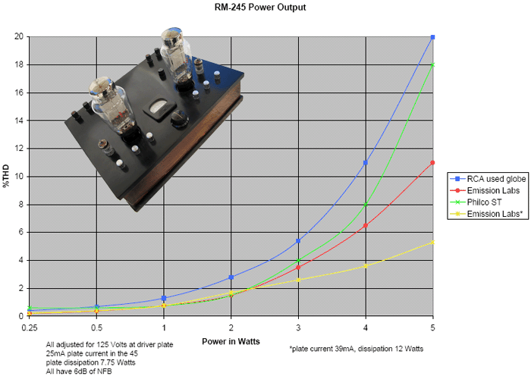
On the subject of tubes, 45 lovers are in luck. TJ and Emission Labs offer current production ones. The above graph is Roger Modjeski's, to show power vs. distortion for his new RM-245. Interestingly, of three tubes tested, the Emission Labs with its top getter (and in both solid-plate and mesh versions) was by far the most linear, suggesting excellent engineering. Owner Anton was an R&D man in Prague's tube factories from 1956 - 1990, then assumed the same role for Alesa Vaic from 1996 - 1998 before Audio Note parted from AVVT and the team around Anton eventually went solo when JAC Music in Sulz-Mühlheim became a partner. JAC Music also imports Yamamoto for Germany. Now Brian Bowdle of Venus HiFi in the US became an agent for EML. This fortuitous development meant that I received a pair of Czech 45 solid-plates to try out and thereby compare them to Shigeki-San's favorites, the NOS Cunninghams that graced the amp as delivered.

