Dipole bass for my ultimate monitor

- Introduction
- Drivers
- Enclosure
- Crossover
- Measurement of the monitor upon the dipole bass
Introduction
When I had finished my ultimate monitor, it appeared that combination with the closed box XLS-12 subwoofer resulted in an unbalanced system. The quality of the bass was not up to the pure reproduction of music provided by the monitor. Because the closed subwoofer was already quite good, I concluded that I needed a substantial improvement. I decided to use the monitor only above 200 Hz, to decrease distortion in the midwoofer during high SPL peaks. Below 200Hz our ear signal processor has difficulty in separation of the direct and indirect reflected signal in the listening room, discreet resonances dominate the spectrum. The dipole bass concept, described so very well by Siegfried Linkwitz on his website, should provide an excellent solution for this in a relatively compact format. So it'd be a dipole bass up to 200 Hz! The area below 40 Hz can still be used to support the lowest octave of the spectrum by the closed XLS-12 subwoofer, the area in which the acoustic shortcut of the dipole bass makes it very difficult to obtain some serious sound pressure.
The nice feedback below is the result of a DIY-listeners day in the Netherlands. As can be seen on the picture, the listening room is far from optimal for the monitor. A pitched roof too close to the speakers and almost no damping. The monitor sounded too clean in this room and the midrange soundstage suffered, but the dipole bass performed flawless.
From the first second it is clear that this is something special! All about this speaker is different, the looks, the soundstage, the response, the acoustics. This alone I consider superb!
The bass is for me the most natural sounding I ever heard. I know by now how a double bass sounds and how it sound live. That is the way it sounds on this dipole bass. Each resonance on the belly, whether desired or undesired, can be heard. Any filtering, compression or coloration remains absent. That I never experienced on a classic speaker. If everyone likes to listen to this I'm not sure, the usual listener has grown up with music out of a box and doesn't know how instruments really sound (I mean without amplification). That's why the lack of pressure or drive will be a disappointment for some. Also the resonances of some instruments could give an uncomfortable feeling. I myself listen analytically and obtain pleasure from such details. For me this dipole bass is fantastic.
Ed Collier
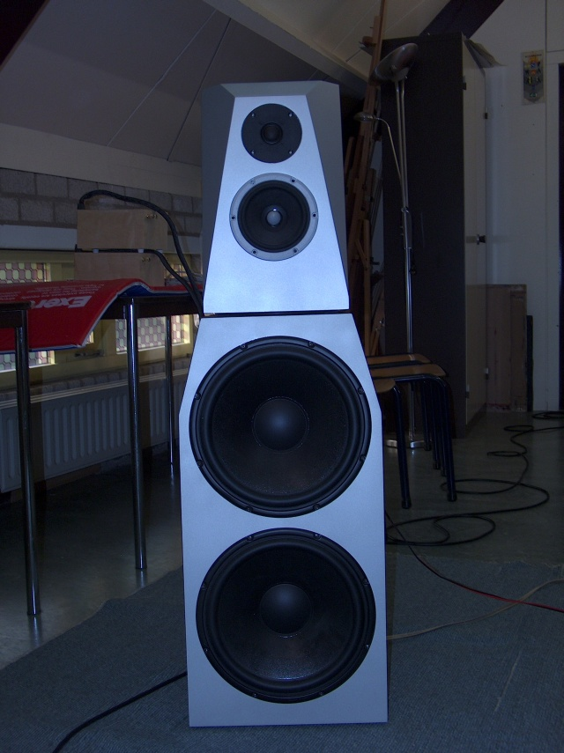
Back to the top
Drivers
A dipole bass needs large and long stroke drivers. This has lead me to subwoofer drivers. I also wanted drivers having a good and almost resonance free response up to 500 Hz. At the Tymphany website I found the Peerless SLS-315 with the name SLS 12" Subwoofer Type Number: 830669. The nice and flat respons comes from a cone not as stiff and heavy such as known from the Peerless XLS-series, but a dipole bass driver doesn't have to cope with high internal sound pressure within a box. Apart from the cone the frame is somewhat lighter but still very strong and open for good backwave airflow. The technology of the motor looks very much like the extremely low distortion XLS-type apart from having only one magnet. Because of the lighter cone it doesn't need a double magnet system for sufficient efficiency.
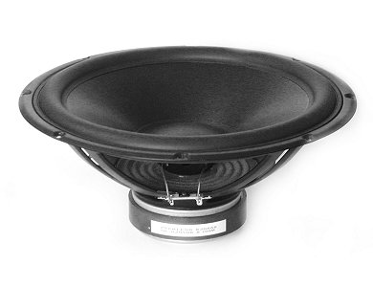
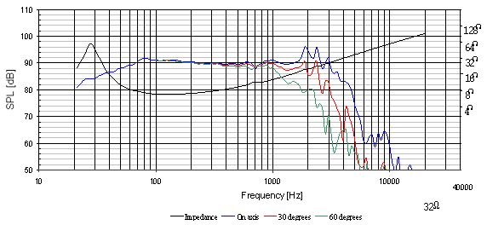
Back to the top
Enclosure
Below a foto shoot of the building proces of the baffle. People who want to know more details can contact me.
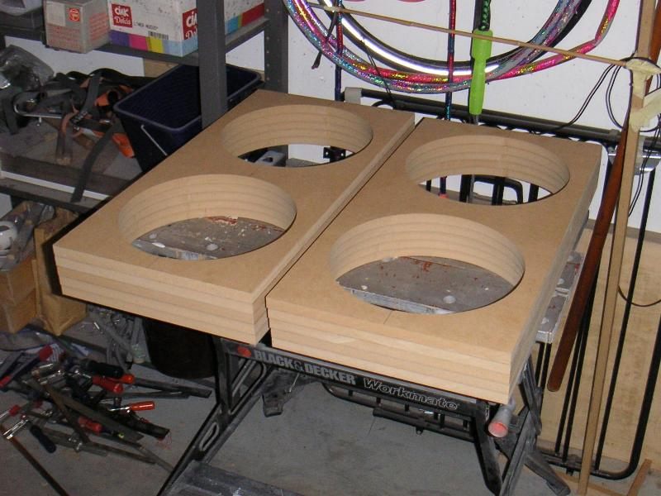
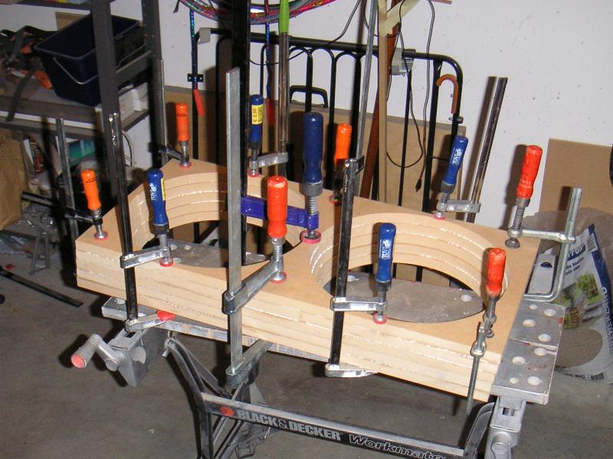
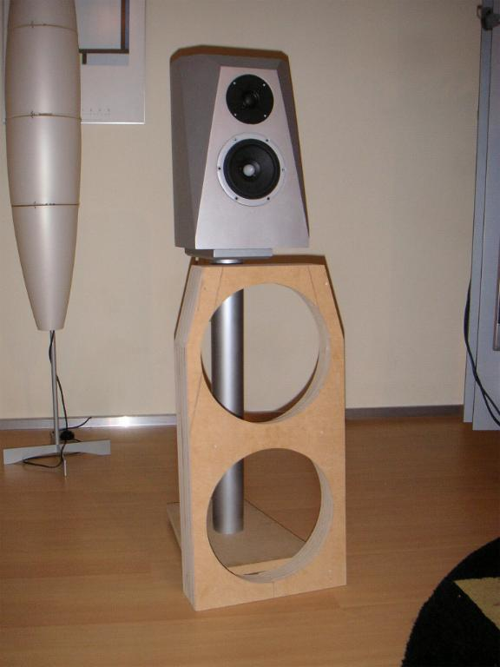
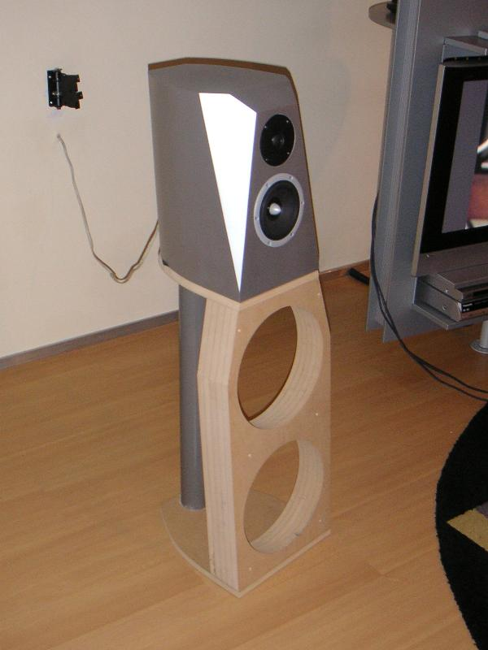
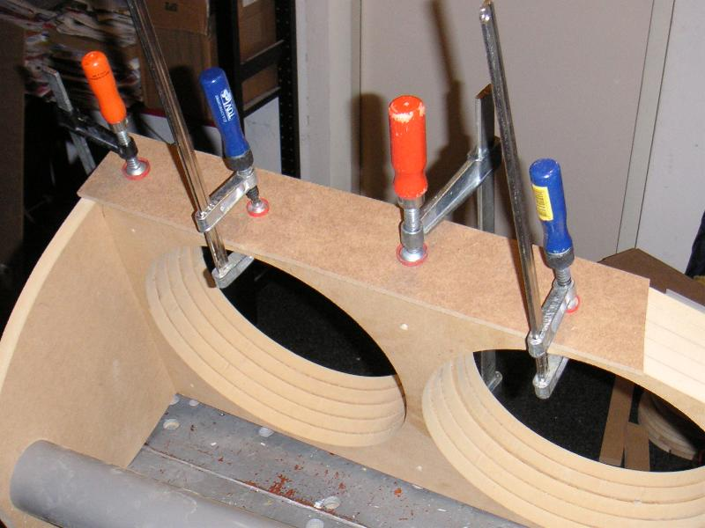
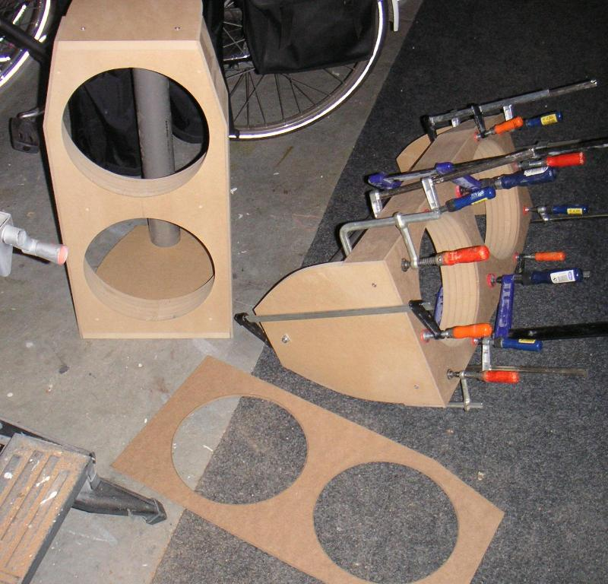
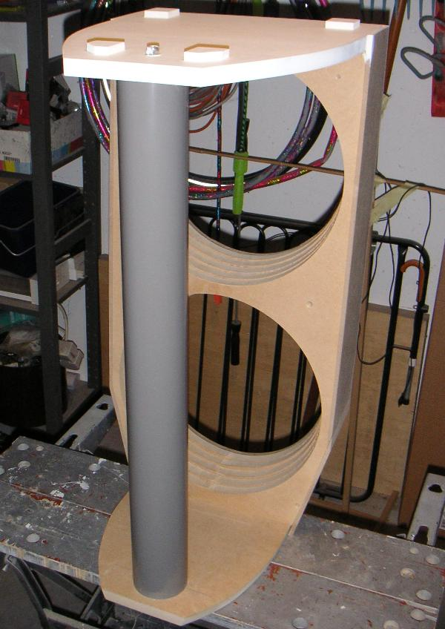
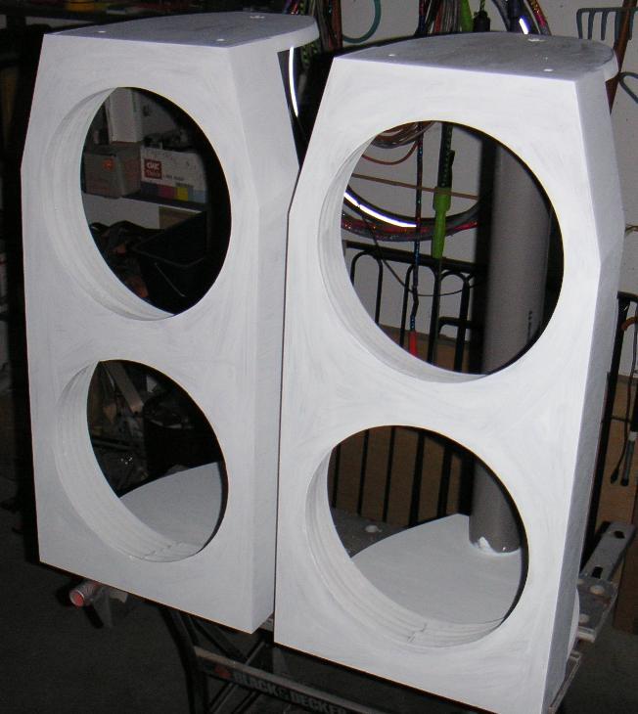
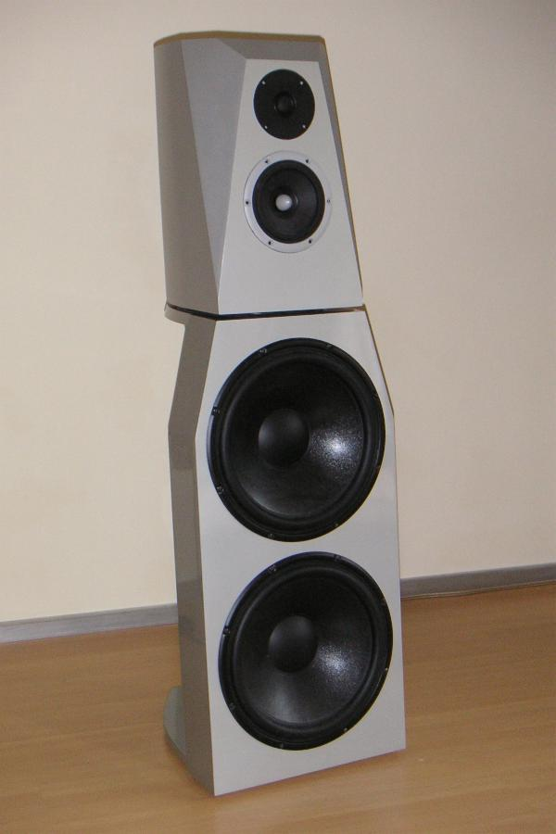
Back to the top
Crossover
The crossover is designed with a minimum of opamps in the signal path towards the monitor. The newest audio opamps of National Semiconductor are used, these are the best opamps I have heard to date. By now also the UcD180 is equipped with the SOIC version of these opamps, the LM4562MA. This lets the UcD-amplifier sound much alike the mids and highs of a class-A amplifier.
The BF245A puts the LME49710NA (opamp U1) in class A by pushing a current of about 4mA into the output. For this the gate and source of this JFET are connected to the output of the opamp while the drain is connected to the positive rail of the power supply. It is there for the perfectionist, for me it didn't really let the opamp sound better or worse.
The acoustic shortcut of the dipole bass, which increases by 6 dB/octave when going down in frequency, is compensated by the circuit around U3B. This circuit works from 28 Hz to 560Hz and flattens the amplitude and phase of the dipole bass across its working range.
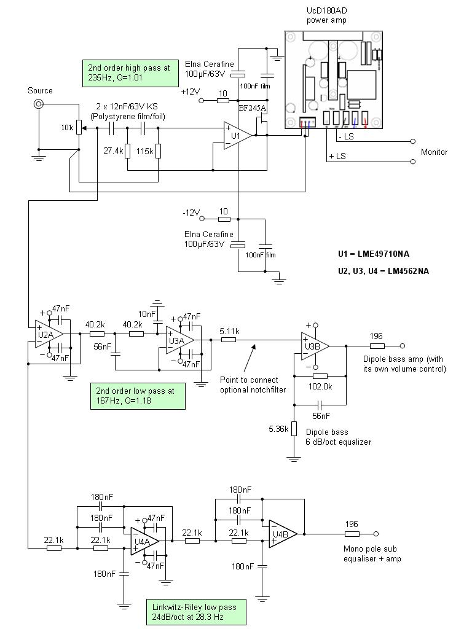
Back to the top
Measurement of the monitor upon the dipole bass
The monitor, still with the SEAS tweeter 27TDC, measured while placed on top of the dipole bass unit. The active crossover was working during these measurements.
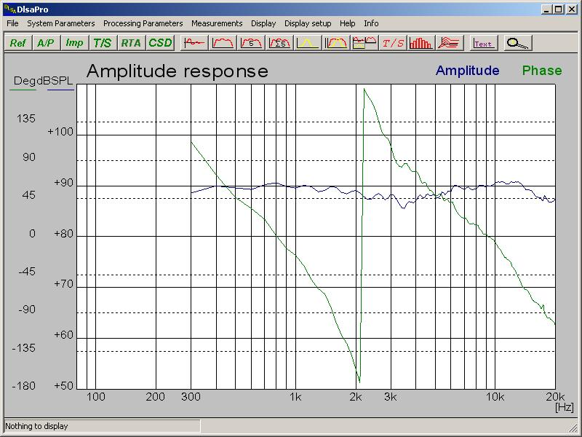
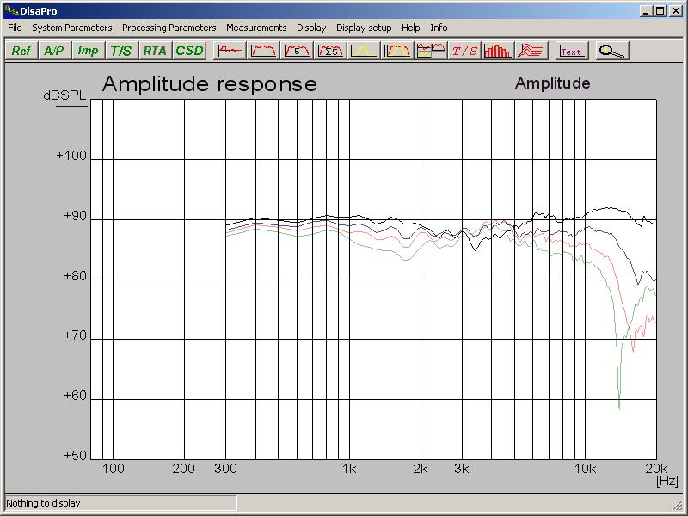
Back to the top

